PAPER MARKED
E

POLICE & CRIME COMMISSIONER FOR

LEICESTERSHIRE

JOINT AUDIT, RISK & ASSURANCE PANEL
Subject | INTERNAL – MAZARS AUDIT RECOMMENDATIONS AND TRACKING
Date | April 2025
Author: | ROY MOLLETT – INSPECTION / AUDIT

Brief Background
- Mazars Auditors undertake an OPCC/Force commissioned annual programme of internal audits; for a number of business functions, and the following are examples of the range of audits undertaken:

Core Financial Systems Counter Fraud / Whistleblowing
Governance Seized Property
Payroll Workforce Staff Retention
Strategic & Operational Business Continuity
Fleet Management Partnerships / Community Engagement
Vetting Portfolio Management Office - Change

Purpose of Report

- The following report provides the panel with update progress responses from business owners in relation to recommendations made so far by external auditors Mazars.

- Mazars assess and grade the recommendations in terms of HIGH PRIORITY , MEDIUM PRIORITY and
LOW PRIORITY risk and report specifically in terms of Risk Management; Value or Money and Sector Comparison.

- The following table illustrates the number of outstanding/progressing and completed proposed closed – high priority, medium priority and low priority recommendations for the Mazar’s audits for this reporting period:

Risk/Priority of Recommendation | Total Reported |  |  | Total running | Completed and proposed closed
 | RED  High | AMBER  Medium | GREEN  Low |  | Proposed Closed | Not Accepted  proposed closed
High | 5 | - | - | 5 | 2 | -
Medium | - | 22 | - | 22 | 14 | -
Low | - | - | 18 | 18 | 12 | -
Total | 5 | 22 | 18 | 45 | 28 | -

- Audit Recommendations Proposed Closed: The following twenty-eight audit report recommendations are proposed closed.
The table also depicts each report title, the section/recommendation reference and the page reference within this report.

Audit Title | Priority Score | Section/Recommendation Reference | Proposed Closed | Page
FLEET MANAGEMENT |  | 4.2 Sample check of service details |  | 6-8
VETTING |  | 4.3. Performance reporting |  | 8-12
WELLBEING |  | 4.1 Review of policies and procedures |  | 13-14
FLEET MANAGEMENT |  | 4.2 Revisit audit repeat Rec - Sample check of service details |  | 20
“ |  | 4.4 Alignment of strategies and delivery plans |  | 21-22
“ |  | 4.5 Tranman user access |  | 22-23
PARTNERSHIPS |  | 4.1 End of contract arrangements |  | 26-28
 |  | 4.3 Compliance agreements |  | 28
 |  | 4.4 Performance monitoring |  | 29
ESTATE MANAGEMENT |  | 4.1 Stock condition survey |  | 29
PORTFOLIO MANAGEMENT |  | 4. Lack of resource profile for the PMOand for upcoming projects |  | 30-31
“ |  | 5. A lack of gap analysis to establish an understanding of available and missing skills |  | 33-32
“ |  | 6. A lack of standardised tools and templates to act as procedural guidance for project managers |  | 32-33
MEDIUM TERM FINANCIAL PLAN |  | 1. Savings plan |  | 33-34
COUNTER FRAUD & WHISTLEBLOWING |  | 3. Recording of whistleblowing allegations |  | 38-39
“ |  | 4. Anti-fraud and Corruption Strategy |  | 40-41
STAFF RETENTION |  | - Multiple Risk Scoring Meethodologies |  | 42
“ |  | - Incomplete Delivery Plans |  | 42-43
BUSINESS CONTINUITY |  | 1. Business Continuity Plan Testing |  | 43
“ |  | 4. Multi Agency Business Continuity Working Group |  | 44-45
OPCC COMMUNITY ENGAGEMENT |  | 1. Develop Annual Communications Plan |  | 45-46
“ |  | 2. Standardised Procedures and Training Sessions |  | 46
“ |  | 3. Communication Protocol reviewed |  | 46-47
SEIZED PROPERTY |  | 1. Guidance for Officers/Staff |  | 48
“ |  | 3. Property Management Procedure Update |  | 49
“ |  | 4. Enhanced security |  | 50
“ |  | 5. Secure Storage and Accurate Labelling |  | 50
CORE FINANCIALS |  | 1. Audit Trail |  | 48-49

- At the JARAP panel in July 2024, the panel requested a table to depict those reported recommendations that have exceeded their original audit report target dates; these are shown in the following table:

Table of Original Target Dates / Current Target Dates – for those recommendations that have exceeded the original target date:

 | Original Target | Current Target | Context
FLEET – September 2018
4.2 Sample check of service details | March 2019 Reliant upon supplier | Qtr 3 / 4 2024 | This is a large complex programme of development which has seen a change in management and is reliant upon suppliers and new IT infrastructure  Now Proposed Closed
4.4 Performance indicators | March 2019 | Proposed closed
VETTING – February 2021
4.3 Performance reporting | May 2022 | TBC – final checks taking place | The lead has been very reliant upon IT, Performance Analysis personnel and software resources  Now Proposed Closed
WELLBEING – February 2021
4.1 Review of policies and procedures | December 2021 | TBC – final checks taking place of the 2 remaining procedures | Consultation and other HR priorities have taken their toll on completing this recommendation  Now Proposed Closed
4.2 Review of thematic data and data analysis | December 2021 | Target date for completion requested | Responsibility transferred and target dates changed – Now sits with Force OH Lead who has listed recent achievements; no update received for April 2025 due to lead being unwell
WORKFORCE PLANNING – May 2021
4.1 Key roles mapping | Pilot June 2021 | May 2025 | Proposal agreed at the People Board; now the proposal is to go to chief officer Exec Board for final consideration.
FLEET MANAGEMENT – November 2021 [Revisit audit]
4.2 sample check of service details | March/April 2022 | Qtr 3 / 4 2024 | As Fleet above  Now Proposed Closed
4.4 Alignment of Strategies and Delivery Plans | March 2022 | Target  end of December 2024 | “
4.5 Tranman User Access | March 2022 | Target  end of December 2024 | “
COUNTER FRAUD – November 2022
4.1 Lack of awareness of the anti-fraud & Corruption Strategy | March 2023 | Revised to August 2025 | Fraud Policy/Strategy revised by OPCC and Force. OPCC also completed the Anti-Fraud, Bribery and Corruption Policy. Communications Plan being taken forward for strategy, policy and training.
4.3 Lack of Fraud Training | December 2022 | Revised to August 2025 | Force Professional Standards Dept rolled out a successful Webinar during 2023 – the 10 standards including Fraud. Training now updated and on force intranet TLA.

- Business leads are encouraged to provide SMART and achievable project target dates for completion. It is clear from the table above there are on occasions where circumstances prevail that are beyond the control of the responsible lead.

- Recommendation

For the board to note the attached summary action updates on progress from business owners against each respective audit recommendation at Appendix A below and the associated evidence embedded within the document.

For the board to consider and where sufficiently evidenced, agree those recommendations proposed closed.

Implications
Financial : | None
Legal : | None
Equality Impact Assessment : | None
Risks and Impact : | Risk to efficiency and effectiveness of business functions where agreed recommendations are not implemented in a timely manner.
Link to Police and Crime Plan : | Transparency and accountability for business functions.

Background Papers
N/A

Contacts

Supt Rob Arthur – Specialist Support Directorate
Email: Robert.Arthur@leics.police.uk

Roy Mollett – External Inspection and Audit
Email: roy.mollett@leicestershire.pnn.police.uk

APPENDIX A

RISK LEVEL | HIGH PRIORITY | MEDIUM PRIORITY | LOW PRIORITY

Audit Title | Risk | Recommendation  Reference | Business Owner – Action Plan Updates
FLEET MANAGEMENT  SATISFACTORY ASSURANCE  September 2018 |  | 4.2 Sample Check of Service Details | Medium Priority Recommendation:  Regular sample checks should be undertaken on the services carried out and the details recorded on TRANMAN. The data should be checked to ensure:  • All details (including mileage) is recorded for the service; and  • The annual servicing timeframe, or the 12,000 miles timeframe, have been met.  The milestones for delivery of the programme of IT improvement have been updated and remain under continued review by ACO Paul Dawkins and Supt Andy Parkes Interim Head of Fleet.  Summary of progress - the following milestones have been achieved between Sept 2018 – Dec 2024:  - The fleet senior management team met with the Civica development team to project plan the significant pieces of necessary work identifying those critical milestones that have to be met sequentially for successful implementation.  - The Force IT department successfully rebuilt the computer system server housing the Tranman program software which is a significant crucial component in facilitating the future fleet system upgrade.  - The server upgrade for the Tranman system was carried out on the 22nd February 2021. This has secured the safe operation of the system for many years.  - All cars are now fitted with Astra boxes and remedial actions are completed.  - On 9th July 2022 the force moved to Tranman 9 and have been using real-time since then. Tranman Release 9 has a much-improved interface, this will provide improvement to data recording, storage and searchability. Efficiency and effectiveness will be improved through improved service centre management information.  - Major milestones have been met with iR3 in terms of the – wider force architecture implementation, reassurance, resilience and integrity and testing.  - Understand and snag test the new Tranman 9 and iR3 interface.  - Develop the test plan for live test of new iR3 with Storm (there is no Storm test environment).  - Test the new iR3 with Storm – iR3 live test completed.  - Snag test and rectify completed Oct/Nov 2022.  - Install new solution for iR3 to report to Tranman (circa 5K LBA).  - Cleanse / improve Tranman data quality – Initial work and new codes added.  - Switch to new iR3 and decommission old iR3 – Soft launch of new Ir3 took place Mid Feb, full-out March. Decommissioning completed.  - Completed the architecture and data flow schematics for T9 / iR3 / Storm / Airwave.  - The Force has completed the selection and testing of suitable computer tablets.  - Challenges with provider external access to the necessary force systems – completed – now resolved for iR3 and via WebEx.  UPDATE April 2025:  What is left to complete and Milestones?  - Changes required to the Tranman system and the introduction of the tablets need to be synchronised in order to maximise efficiencies. This requires the creation and manual inputting of specific service requirements, parts needed for routine servicing etc in order to link in with stores and ordering.  - The correct Tablets have now been received, and are being introduced incrementally to the technicians and we are in constant dialogue with Civica over functionality and solutions – due to be fully rolled-out including training by end of June 2025.  - Understand and exploit new functionality (including tablets) and the impact on future vehicle fleet management solutions. Bluelight Commercial are undergoing a tender process due to be completed in July 2025. This may impact future decision making around the chosen system – Q3/4 2025.  Barriers to completion, and how these may be resolved where possible?  - Workload demands on key personnel (no dedicated resource to iR3 / Tranman) – work underway to automate many processes. Partially completed – further staff losses in Q4 2024 have impacted significantly on the capacity to complete the scheduling. Revision of posts and recruitment to follow in Q1/Q2 2025  - Recent changes made by BT / EE as part of the forces SIM provision has caused failures with the Astra Boxes. As of April 2025, this has still not been resolved and IT Comms / LBA are in constant contact with BT/EE.  - Further funding likely to be required for additional Tranman modules. Still in negotiation as per above.  Risk Mitigation – The following mitigation is in place to ensure force vehicle service schedule points are met:  - Cars with Astra box can be mileage tracked on new iR3 and called in for service.  - Service stickers are applied to the car’s interior after each service identifying the next mileage point the car is due in – these MUST be checked as part of daily vehicle check and adhered to.  - Mileage data from fuel cards utilised to identify service mileage points. Correct mileage MUST be supplied to the cashier for accurate mileage data.  - There is now an accurate feedback loop from iR3 to TranMan regards mileage and work is in progress to build service schedules – ongoing build  Using the above four data sources, the TU are able to identify the service points for fleet vehicles.  Messages have been published on the force intranet and through management teams instructing personnel to follow the above instructions to enable correct vehicle servicing to take place.  Is the recommendation ‘proposed closed’? Yes - Proposed closed  Enormous progress has been made with the team delivering some really positive progress. Earlier this year in February a progress update presentation was provided to the Joint Audit and Risk Assurance Panel JARAP regarding the fleet which it is hoped was found to be both informative and interesting.  I believe the recommendations can be closed at this point as the outstanding elements are in essence ‘business as usual’ and in-hand and the reasons the original recommendation were made have now been addressed and mitigated.  The current challenges with EE/BT are arguably BAU as it has been caused by third party supplier and is not a fundamental aspect of the solution. The situation has improved enormously over recent months and where non-compliance with service requirements are identified, supervisors are informed at the relevant location / team - Supt Andrew Parkes  PROPOSED CLOSED
VETTING  SATISFACTORY ASSURANCE  February 2021 |  | 4.3 Performance reporting | Medium Priority Recommendation: The Force should ensure that performance information is produced for Vetting, with consideration made to enhancing the data that is included within the performance indicators.  The vetting performance information that is produced should be presented at the Professional Standards Department (PSD) Senior Management Team (SMT) meetings.  Examples of further indicators that will enhance the reporting are:  - The number of cases received in the month  - The number of cases processed in the month  - The % of renewals processed prior to the expiry date  - Exception reporting on significant outliers in cycle / touch time  - The proportion of each type of vetting case received within the month  - The turnaround time on vetting appeals that are processed.  Management Response: Currently, MI reporting responsibility sits outside of the Vetting unit and therefore is not within the direct control of the Security Vetting Manager.  1). Outstanding PSD performance reports for March 2020 – January 2021 have been obtained since the draft audit report was received. COMPLETED – Outstanding PSD Performance pack was obtained on the 8th of February 2021 – Supt Rich Ward  2) In line with the audit recommendations, the reporting categories and KPI’s are to be reviewed by the Security Vetting Manager who will act as Subject Matter Expert to the SSD Performance Analyst lead, for the development of a Strategic and Operational Vetting dashboard.  Target Date: January 2025 – Mandy Bogle-Reilly (Security Vetting Manager)  Achievements 2021-2023:  New Corevet Version 5 vetting software was successfully installed on the 5th of July 2022.  The vetting team have reviewed the standard Management Information MI reporting capabilities afforded by Corvet before moving into phase two which entails the development of an interface between Corevet, HR Gateway and Establishment records into a new front end Vetting Dashboard / Application App.  Progress is currently delayed due to a shortage of analytical resource within the Force PowerBi Analyst Team. The Vetting Unit cannot as yet progress to the final stage of the project to create the Vetting Dashboard/App, therefore at the moment there is no change to the status.  In the interim, the Vetting Manager and a team member are developing a simplified suite of in-house monthly reports to support the current manual audit and performance reporting, until such time a Power BI resource is made available.  The position has been escalated to the Analyst Team Manager and the Head of SSD.  The Analyst team manager and Senior Performance Analyst have met to scope out the future Power BI development work required. It is understood it is likely to be a challenging and complicated product with a need to cross-reference data from Derbyshire (recruitment), Leicestershire’s HR and establishment systems.  What is left to complete?  - Secure the necessary PowerBi analytical resources to support development.  - Scope the system interfaces and the reporting dashboard.  Milestones – Timeline for completion:  - The timeline for completion is entirely dependent upon the availability of resource from the force Power BI team. Timeline for individual final workstreams are to be confirmed.  Barriers to completion, and how these may be resolved where possible?  - Failure to provide adequate resource from PowerBi or specialist support will prevent any progress with development of the dashboard.  - Complexities related to system interfaces and the reporting requirements for the dashboard.  It is understood that it is unlikely that the system will be able to address the issue around notifying vetting of changes to personal circumstances that would require additional vetting. This may however be possible from the data fields in HR and Corevet; however, until the team start the process this remains an unknown.  - The size of the performance analyst team and their current commitments, means there are challenges around capacity to provide analytical support and development of the PowerBi App without the removal of support to another area of business elsewhere in force.  Update January 2024: The D/Supt head of department met with the forces’ Corporate Services Analyst Manager and the Principal Analyst on Friday 12th January 2024 regarding ‘Service Layer’ work that they are undertaking.  The outcome of the meeting was that as part of the service layer work, the force vetting unit have been assigned an SSD Performance Analyst to support the development of both PSD and Vetting Power BI dashboards. PowerBi should be able to extract all the required data from the various sources and present into a constructed real time dashboard/App.  The Head of Department and I will meet with the assigned analyst very soon to take this forward but in the interim I attach a copy of the latest monthly Vetting dashboard, Refusal data and Disproportionality report that we created in house which provides basic performance reporting. I’ve redacted the Refusal data to anonymise names – Mandy Bogle-Reilly Force Vetting Manager. [Documents Monthly Vetting Stats; Protected Characteristics and Disproportionality removed as these were submitted for the last JARAP.  UPDATE July 2024: No change – The force Vetting Unit are still waiting for the Specialist Support Directorate SSD to finalise this piece of work for Professional Standards Department PSD. Vetting are in the interim running with the in-house dashboards previously submitted to JARAP which meet the MI requirements but are time consuming - Mandy Bogle-Reilly Force Vetting Manager.  The force T/Principal Analyst has developed both the PSD and Vetting Apps; and resources have been assigned temporarily to pick up this area of business, however it is still in the early stages of development.  The Vetting App was initially created a few months ago, however the force principal analyst is aware vetting are changing systems therefore this will need to be revisited.  The principal analyst will provide access to both Apps – Vetting and Professional Standards once fully developed and completed.  Please see the current SharePoint PowerBi Dashboard screenshot for Vetting here:  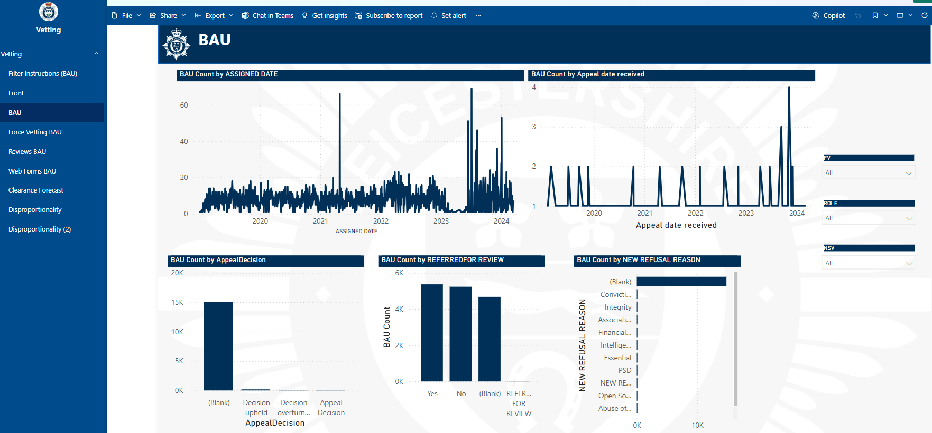  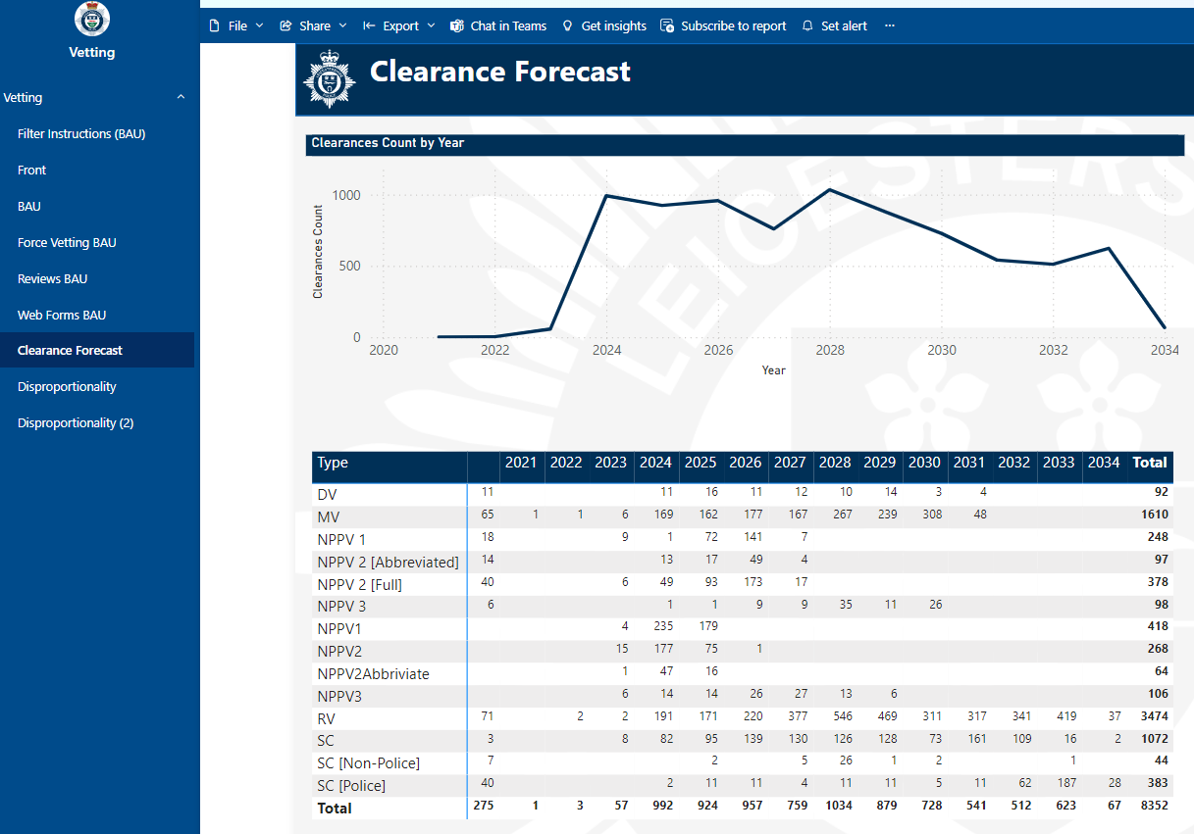  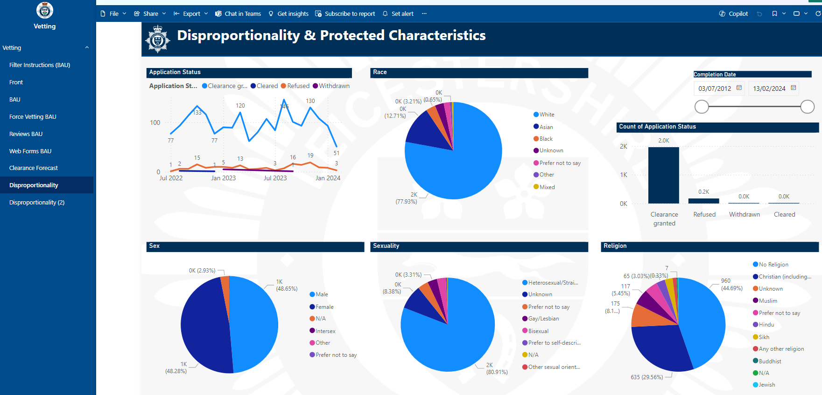  UPDATE April 2025:  What has been achieved? The Dashboard has been created which depicts – business as usual in terms of applications etc; Clearance Forecast and Disproportionality and Protected Characteristics.  The vetting unit have undertaken testing in conjunction with their analyst in relation to the output from the PowerBi App to see if it is consistent and accurate when compared to the manual records held within the unit – the results were positive and the performance output appears to be accurate.  What is left to complete? Nothing  Any barriers to completion? None  Is the recommendation ‘proposed closed’? If so, please provide sufficient narrative and evidence to support closure i.e. explain how the recommendation has been achieved and provide - documents, performance reports; anything that proves the recommendation has been met.  Yes. The Power BI App  is functioning as expected and will be modified as and when new KPI’s are required or as directed by the force and HMIC  PROPOSED CLOSED
WELLBEING  SATISFACTORY ASSURANCE  February 2021  “ |  | 4.1 Review of Policies and Procedures | Low Priority Recommendation: The HR procedures which have been identified as out of date through our review; the tracking of previous recommendation; and the SORB monitoring activity should be reviewed and updated.  The Force should ensure that policies and procedures are reviewed regularly; and, that this is noted in the document control sections even if no updates are made.  Initial Management response: The recommendation is accepted, and the progression of the full range of policies, procedures and guidance is a huge task due to the sheer number of these. They will be moved forwards and the document which confirms what stage they are at will be updated as suggested regularly even if the updates are still being worked on. None of the procedures are out of kilter with current legislative compliance to provide some reassurance.  Target Date: Target date March 2024 – Kat Eaton Head of HR / Bharti Mistry HR Administration  Type Title of Policy, Procedure, Form Date of next review Update Current status  Procedure HR – Redeployment as a Reasonable Adjustment - Police Staff Nov, 20 Completed The procedure has now been reviewed and published on the force intranet  Procedure Honoraria - Police Staff Sep, 20 Completed now Pending sign-off Review and formal consultation completed – to go to JNCC 1st May 2025 for final sign-off.  The force recognises that this is a suitable moment to apply some of the design development and improvement work to make the process more efficient and effective in supporting personnel across the force.  Of the 15 policies and procedures originally identified as out of date through the audit the above Honoraria – Police staff is still undergoing the consultative review process to ensure that they appropriately support personnel across the force.  The Procedures do take longer to review as they outline more complex matters concerning the expectations of the force and other stakeholders such as unions and staff associations.  UPDATE October 2024:  The Redeployment as a Reasonable Adjustment is currently out for final consultation with the view that it will be presented for sign off at the next JNCC in October 24.  The Honoraria Procedure is at the point where formal consultation should start in the next couple of weeks. There has been some delay in progress here from the last update as the person leading the review is embedded in the Hay Project which is in the process of implementation ahead of go-live.  I am hoping that by the next update we are in a position whereby things have progressed forward but due to competing demands we have not been able to progress as hoped - Kat Eaton Head of HR  The HRBP leading this is heavily involved in the delivery of Hay so over the past few months it has been challenging to progress as hoped. However, the procedure is drafted, and informal consultation has taken place. The intention is to have the procedure to the unions for formal and final consultation in the next 2 weeks (13.09.24)  UPDATE April 2025:  What has been achieved?  The Redeployment as a Reasonable Adjustment The procedure has now been reviewed and published on the force intranet – copy provided:  What is left to complete?  Formal sign-off - The Honoraria Procedure has now been reviewed and formal consultation completed; the procedure will now go to JNCC for formal sign-off on the 1st May 2025 - Kat Eaton Head of HR  Any barriers to completion?  None identified.  Is the recommendation ‘proposed closed’? Yes – Proposed closed subject to approval of the Honoraria Procedure at JNCC - copy embedded above and provided to JARAP.  If so, please provide sufficient narrative and evidence to support closure i.e. explain how the recommendation has been achieved and provide - documents, performance reports; anything that proves the recommendation has been met.  PROPOSED CLOSED
 |  | 4.2 Review of Thematic Data and Data Analysis | Medium Priority Recommendation: The Force should ensure that data, outlined on each working group’s Plan on a Page, is being reviewed regularly and that any data analysis requested is being carried out effectively and shared with all relevant governance bodies.  Historical Achievements 2021- January 2024:  - The 5 Wellbeing Boards are developing - data analysis against their plans, incorporating a benefits assessment of initiatives and working practices.  - Data packs exist for the Wellbeing Board, Mental Health and Physical Health Data. These are produced by HR until the Power Bi work has moved forwards.  - The wellbeing KPIs were taken to the Chief Officer – Executive Group and it was agreed that further work was required.  - Currently refining the workforce wellbeing enabling strategy and the associated KPIs; when agreed the KPIs will be part of the Power BI build and GAIN modelling tool.  - Force Performance Analysts - It is recognised that the app will be the most complicated app built thus far - estimated completion time 18 months.  - Wellbeing KPIs remain in development, in the interim, a Wellbeing Data Pack is submitted to the quarterly Wellbeing Leadership Board which provides an overview of all wellbeing activity under the 4 strands of wellbeing and against the national framework.  - Wellbeing data November 2022 – provided at the last JARAP in April 2023  - A new Head of Occupational Health and Wellbeing OHW was appointed in early 2023 at which time strategic responsibility for wellbeing with transfer to this role and the KPIs will be further developed in conjunction with the chief officer team – Kat Eaton Head of HR  - The overall strategic governance for Occupational Health and Wellbeing now under newly formed ‘People Board’ – first meeting convened on 1st July 2023 and chaired by the ACO Human Resources.  - The whole strategic delivery of Occupational Health and the various Wellbeing support strands are currently under review. The purpose of the review is to ensure that OH and Wellbeing are synchronous and developed in tandem.  This will provide a much greater understanding of the challenges faced by personnel, thereby enabling the force to target the areas identified as of highest concern, for example where additional support may be required to address stress and mental ill-health.  - Data / Key performance Indicators -The Plan on a Page, data and key performance indicators KPIs are also under review by the Data Working Group. The group consists of – ACO HR; the Head of HR, the Head of OH and Wellbeing, the Head of the Team Leicestershire Academy and the Head of East Midlands Specialist Learning and Development Hub (EMSLDH). The objective is to review existing and develop any new KPI metrics required to inform strategic and service delivery decision making.  - Data management reporting will be via a progressive PowerBi application.  - Existing KPI data sets – examples provided at the last JARAP are currently being used in the interim transition phase.  - Capacity and capability increase - Wellbeing Lead / Co-ordinator – A new role to be recruited to oversee – data collection, analysis and coordination of the OH and Wellbeing Strategy and feed into the Head of OH/Wellbeing and ultimately the People Board.  - OH and Wellbeing has been included within the Force Management Statement FMS which examines demand, capability, capacity and developments going forward.  Developments so far are a positive step forward as it will streamline processes, practices; inform service delivery and enable the force to focus on what really matters most to the organisation and our workforce. Tim Ellis – Head of Occupational Health and Wellbeing - Target date: March 2024  UPDATE January 2024: Occupational Health and Wellbeing has undertaken a number of activities to help address the biggest health related risks - mental health, long term absences and restrictions, physical fitness.  - Improved access to mental health therapies- removal of red tape  - Upskilling managers in the role of OH and Wellbeing  - Upskilling clinicians in broadening their knowledge of roles by way of operational visits, closer working with HR and TLA etc  - OH inputs delivered at network events, forging closer links with staff support groups  - OH is now an integral part of complex case review meetings as well as Gold and Silver meetings  - Implemented stage 1 of the Cority OH case management system  - EAP via Health Assured- closer links forged with their contract management and clinical teams to ensure any problems are captured early enough and addressed, ensuring our staff are getting value from this service.  - “Power to Recover” Trauma coaching service via the EAP- new service implemented and communicated to the workforce; anyone who has experienced a traumatic event at work can speak to the EAP and start a guided programme with a qualified trauma coach.  - SPS (structured professional support) via Health Assured- annual or 6 monthly psychological assessments for all staff identified, conducted by a trained therapist. Risk level is based on the Oscar Kilo guidelines Psychological surveillance | Oscar Kilo but Leicestershire Police go above and beyond their programme by offering out to more teams than Oscar Kilo recommend.  - TRIM – Leicestershire Police has had a well-established TRIM referral process and dedicated team of trained assessors. Close links have been forged between the assessors and the OH and Wellbeing support services to ensure support is available for people in need.  Remaining to complete:  - Data and KPI’s for the above work is still in transition. OH, data is kept in a number of different places now as we move as a team from Cyclops to Cority. Suppliers such as Health Assured and Sano physiotherapy provide data which we will incorporate into other OH datasets.  - Wellbeing work has transitioned across to OH from HR but still a gap in establishment with the Wellbeing Lead role. The lead role will coordinate and oversee strategic activities and data reporting.  - Previous wellbeing strands to be retired off in the old format and in its place, install a new and invigorated Wellbeing champion structure.  - More work to be done with Resource cell and Strategic ARM to review number of officers on restrictions.  - Overall People Directorate Power BI, KPI and data packs still being discussed at People Board and SLT level.  UPDATE October 2024:  What has been Completed?  - Cority now able to report on OH usage data and KPI’s. First round of data fed to PowerBi team in force for analysis and inclusion for People and Strategic Delivery Board SDB boards.  - Wellbeing Lead now in role, 12 month secondment. Additional secondment roles to backfill agreed via Strategic Vacancy Control Board SVCB. 1 post filled with second out to recruitment. Further backfill for Gym Coordinator role also in progress.  - New structure called WellNET now in place, replacing the previous wellbeing strands. Governance wise, the WellNET forum is run by the Wellbeing lead, with escalations and pouring into People Board via Head of OH and Wellbeing. “WellNET enabler” and “WellNET ambassador” (former wellbeing champions) groups set up to spread wellbeing messages and activities across the force.  - Gym committee under OH and Wellbeing now, plus plans for Force Sports and Leisure FSL activities to migrate across in October 2024  - Work with strategic ARM team ongoing with more officers put through OH and fitness referrals  - Welfare silver and CAID review meetings in place.  - OH representation on recruitment “Fit to Proceed” panels now in place.  - OH and Wellbeing strategy being re-written.  - Blue Light Wellbeing Framework- significant work undertaken to review and RAG status the full BLWF suite of questions (100) as laid out by National Police Wellbeing Service (NPWS).  Tim Ellis – Head of Occupational Health and Welfare Target January 2025  UPDATE April 2025: Lead unwell at the time of reporting
WORKFORCE PLANNING  SATISFACTORY ASSURANCE  May 2021 |  | 4.1 Key roles mapping | Medium Priority Recommendation: The Force should complete a mapping exercise and produce a centralised log of all key staff roles across the organisation, including non-leadership roles which are critical or specialised.  Alongside this exercise, individuals who are able to assume these positions in a short / medium / long term capacity should be highlighted.  Initial Management response: Accepted. It is noted the observation is in relation to ‘staff roles’. The Force has a relatively flat hierarchy for staff roles typified by significant distance between roles at a senior level.  The Force will create a framework for succession planning that will identify the scope of senior and other critical roles. The framework will identify for each role individuals capable to step in on a short term/emergency cover basis, and those who are anticipated to be ready in medium and longer timeframe. This will allow for targeted development and plans to manage where succession gaps are evident – ACO HR Alastair Kelly  Achievements May 2021 – March 2023:  A Working Group established to scope, develop and implement a Succession Planning Framework focused specifically on senior and critical police staff roles within the Force.  The force certainly recognises the business benefits of the Succession Planning Framework for police staff in that it will:  - Inform appropriate plans for development, recruitment and business continuity; enabling managers to identify areas of staffing risk and mitigation;  - Provide a mechanism for line managers to identify police staff roles considered as ‘key’, critical posts;  - Identify possible successors and possible timings around succession and any development requirements.  - Where successors are not apparent in the short and/or longer term, it enables managers to consider other means of planning e.g. proactive recruitment, development of regional networks to help mitigate risk;  - Identify individuals that may be able to develop into a particular roles;  - Identify where outside resources may be required in the event of unforeseen loss of key personnel;  The toolkit has been presented to, and is supported by the Assistant Chief Officer ACO for Human Resources HR.  A presentation that outlined the initial draft Succession Planning Toolkit has previously been shared with the JARAP panel.  Due to a long-term absence a new Leadership and Management Business Partner within the Team Leicestershire Academy TLA was appointed to lead on this important piece of work.  The lead has met with those staff previously supporting the original pilots of the succession planning for police staff from a HR perspective to understand the findings from the pilots. One of the key decisions of note was the need to simplify the process from its original 6 steps. The team identified which steps were of most value and recommendations made in favour of a simplified 3 step process as follows:  Step 1 – Identify Critical Roles – This enables a manager to look at the police staff roles within their team and identify critical roles through a scoring matrix with a focus on those that are at high risk of becoming vacant within the next 2 years.  Step 2 – Identify Specialist Skills – Where a high-risk critical role is identified, build a role profile to identify specialist skill sets of that role.  Step 3 – Create a succession plan – Initially reviewing the aspirations of people within their team for potential successors with whom you can implement a development plan. Where a high-risk critical role does not have an identified successor, this should be flagged on the Force Management Statement FMS Organisational Risk Assessment ORA.  Next steps include the development of an electronic version of the revised form to be piloted within the TLA with a view to a Force wide launch by September 2023.  A meeting was held with both the Chief Constable and Assistant Chief Officer ACO Human Resources on the 13th of March 2023 to provide a full update on the proposed Leadership and Management Development, strategy, structure and offer of which this workstream was also presented. The proposal and direction of travel was met with a positive response.  Change of Lead - Achievements April 2023 – Jan 2024:  - Identified as one of 10 key workstreams sitting under the governance of the Leadership Development Working Group.  - Refinements made to the toolkit/forms.  - The pilot for the next testing phase of the succession July.  - Designing a new Microsoft form with our Digital Academy lead.  - Awaiting the new HR Business Partner to be appointed who will support roll out.  - Exploring the possibility of this forming part of the PDR system as a longer-term goal.  - The Microsoft Forms to collate and inform succession planning requirements have been designed and tested by HR and TLA leads with some further amendments necessary ahead of the pilot.  - Delay due to the TLA Developer who designed the App leaving with final amendments yet to be completed. Therefore, until a new person is appointed I’m unsure where I go with this as I am unable to launch the succession planning without a finalised App.  - The PDR working group have this in scope for integration into the PDR App as part of ongoing PDR development,  - Career, Succession Planning and Promotional requirements to brining this altogether as a future aspiration.  - The finalised toolkit ‘Go live’ target date: September 2023.  - Briefing HR Business Practitioners to support suitable communications and engagement across the force.  The form now consists of 3 key stages – please examples inserted below:  - Annual Role Review Form – to identify Specialist/Senior Police staff roles that may become vacant in next 12 months  - Role Succession Plan Form – to identify individuals who could be considered for succession planning  - Create a Succession Plan Form - a development plan and timeline for succession planning of those individuals  Update July 2024: Currently there is no replacement for the Digital Academy Lead. A paper relating to the Digital Academy was presented to the People Board and Business Delivery Board to update that due to the financial climate and the recruitment freeze this post was placed on hold. Only essential maintenance can be undertaken at the present time. This is due to be reviewed at the end of the year.  It has recently been agreed to recruit into a 12 month fixed term contact for the Career and Talent Lead, which will oversee this work – however this has only recently been circulated for advertising.  HR Services and the Team Leicestershire Academy will review as staffing and capacity changes.  UPDATE October 2024:  What has been achieved? The templates are loaded onto the TLA webpages and are available to use however there are still improvements to be made which has not been feasible as the position responsible for this work was removed as part of the force savings requirement.  HR have run the process as a trial with a number of departments including Finance, TLA, Change Team, Procurement, Estates in 2023. TLA are going to run the process again to check the templates are all working correctly.  What is left to complete? Once HR have the new TLA data, further work will be required in conjunction with EMSLDH to transfer the data into PowerBI and create a meaningful output for HODs. As at the moment it captures the data into an excel spreadsheet that is very large and difficult to interpret.  Any barriers to completion? We have to submit the request for EMSLDH work to their project board and wait for it to be assigned a project officer. Also, the Career and Talent Lead mentioned above, doesn't commence in post until January 2025.  Is the recommendation ‘proposed closed’? No  If so, please provide sufficient narrative and evidence to support closure i.e. explain how the recommendation has been achieved and provide - documents, performance reports; anything that proves the recommendation has been met.  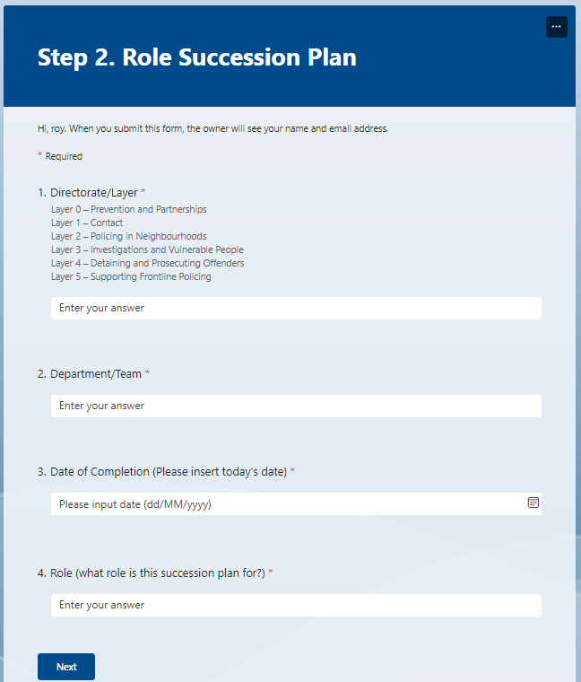  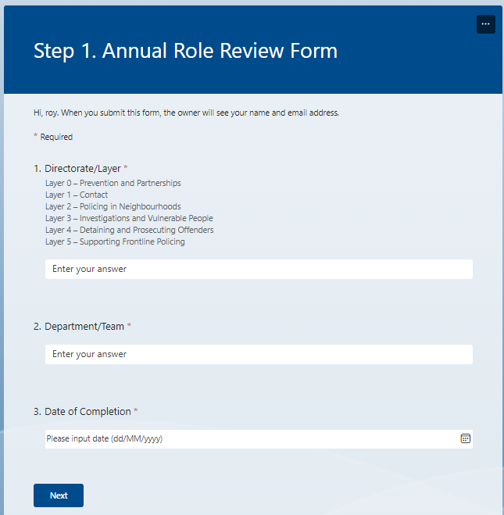  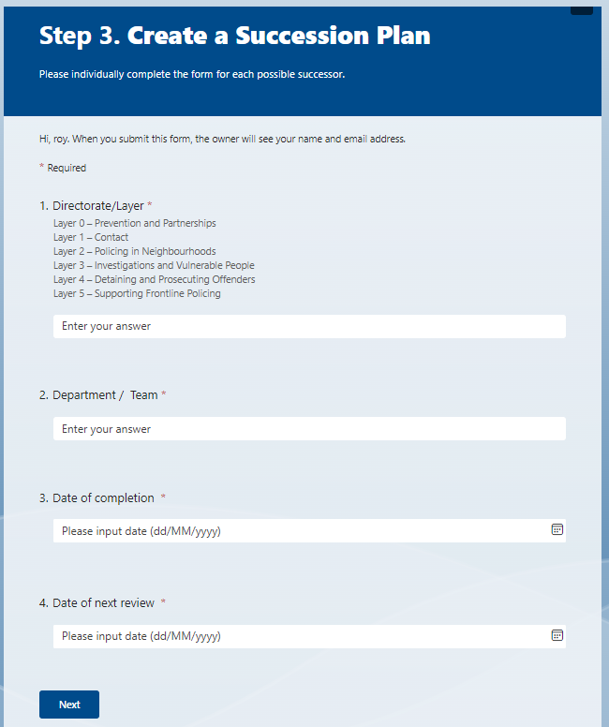  UPDATE April 2025:  What has been achieved?  A Succession Planning Working Group has been convened and they have been meeting to fine tune the MS form and more importantly the outputs.  A force lead on the College of Policing Talent Management has been appointed and it is understood that this area of business now falls within her remit.  The MS form has been presented back to ACO Kelly with a query on how far the form is to be rolled out i.e. - specific roles, staff only or the whole force.  A draft Succession Planning Proposal was submitted to the People Board on the 9th of April at which it was decided to roll it out for the whole force, all roles. The proposal will now be submitted to the force Chief Officer Executive Board inn May for final consideration and approval.  What is left to complete?  The new lead has prepared a paper for the chief officer team Executive Board to consider.  Any barriers to completion?  None identified.  Is the recommendation ‘proposed closed’? No leave open  If so, please provide sufficient narrative and evidence to support closure i.e. explain how the recommendation has been achieved and provide - documents, performance reports; anything that proves the recommendation has been met.  HMIC PEEL Inspection reports search – What HMI looks for in this area? – copied to ACO Kelly HR, Head of HR and Team?
FLEET MANAGEMENT  (Revisit Audit)  SATISFACTORY ASSURANCE  November 2021 |  | 4.2 Sample check of service detail | Medium Priority Recommendation: It should be ensured that:  - Where a vehicle has a missing or non-functional black box, this is resolved promptly.  - A process is put in place to allow for the mileage of covert vehicles to be made available promptly upon request.  - A vehicle servicing policy or procedure document should be created, this should include the mileage guidelines for servicing, information around exceptions such as the allowed leeway in mileage, and how covert vehicles are dealt with.  Initial Management Response:  A fully functioning tracking system along with the replication of the vehicle service schedule within iR3 will overcome potential issues with service intervals being missed. Vehicles that do not have tracking systems fitted, covert/surveillance vehicles, have tended to adhere to the appropriate service regime but it is recognised that a clearer defined process for reporting mileage will help avoid missing any service intervals. An appropriate servicing guideline document will be created for submission and ratification by TUB.  This is a revisit repeat recommendation  For the update, please see 4.2 Sample Check of Service Details - pages 6 to 8 above.  There have been recent challenges in the data loop system created by a third party provider (EE) making changes to their SIM network. These have been resolved in the last 2 weeks and we are now in a position to configure the service scheduling as detailed in the response above.  PROPOSED CLOSED
“ |  | 4.4 Alignment of Strategies and Delivery Plans | Medium Priority Recommendation: The Force should ensure annual business plans are aligned to the overall Transport Strategy. The Force should review how it will report on delivery of the ‘eco-efficient transport solutions’.  Initial Management Response: The annual Transport Unit business plan is largely aligned to the Transport Strategy. The strategy of an Eco-efficient transport strategy must be balanced against the needs of the police force and its operational requirements, appropriate vehicles in the marketplace, infrastructure and budget considerations.  As part of the vehicle procurement strategy adopted thorough discussions with force fleet leads and Transport User Board, the decision was made to move away from diesel vehicles for general response vehicles. The need for inclusion of this target in the Transport Unit business plan is noted and will form part of future plans.  Reporting around the environmental impact of the fleet was withdrawn as accurate data on vehicle use was not available. This will be reinstated when the tracking system roll out has been completed and accurate data can be referenced. Reducing the carbon emissions associated with the force’s fleet is included within the draft environment and sustainability enabling strategy.  Update April 2025: The work that has been completed within TranMan and iR3 will now be able to form the basis of the business plan going forwards. With accurate vehicle utilisation data now available, work can begin to understand the future fleet and infrastructure requirements.  This will also allow us to better understand our environmental impact as the data is far more accurate.  Achievements to date:  - All new General Response Vehicles GRVs and high-performance vehicles are petrol or MHT  - New interim Head of Fleet appointed who has attended national meetings and conferences relating to the move to EV  - CC’s new car is petrol-electric hybrid, and a charging point has been installed at FHQ  - Demonstrations and tests are being arranged for EV / PHEV etc  - Head of TU and estates have had several discussions around future infrastructure requirement.  - A Sec106 bid has been put forward for 5 electric vehicles, (4 enquiry cars and 1 cell van and associated charging infrastructure). Bid approved at Force Exec Board – pending drawdown of funding – Bid agreed by PCC – Around 80k has now been drawn down.  - Refresh of the Fleet Strategy completed - Note: Transport Strategy provided at April 2024 JARAP.  - Initial site assessment for fitting of EV charging points for trial completed.  - Installation of charging points for trial of EVs (5 sites (FHQ, Mansfield House, Euston Street, Keyham Lane and Loughborough). A procurement process was completed although this was not straightforward and the ‘winning’ bidder then significantly increased costs. Alternative solutions have been identified and an SSD is being prepared by estates in order to award the contract. Estimated completion of installation by end of the calendar year 2024.Contracts now signed and work due to commence imminently. The work has been completed and all charging points are active.  What is left to complete? N/A Completed  Timeline for completion N/A  Barriers to completion, and how these may be resolved where possible? N/A  Is the recommendation ‘proposed closed’? Yes - Proposed closed  Proposed that this recommendation is now closed as completed. Estates and Fleet have worked closely on the infrastructure project and are aware of the need to ensure that strategies are aligned - Supt Andy Parkes Head of Fleet.  PROPOSED CLOSED
“ |  | 4.5 Tranman User Access | Low Priority Recommendation: A review of user roles within Tranman should take place, and a new standardised set of user roles should be implemented.  Initial Management Response: As part of the new TU Transport office managers role, reviewing systems and processes has been assigned as an objective. A review of Tranman was already underway at the time of the audit. This should be implemented within the next few months when Civica, the supplier, can accommodate the change request.  Progress Update April:  Achievements to date:  - Move to Tranman Version 9  - Vast improvement in data quality in TranMan  - Civica attended FHQ to make changes to TranMan and compile improve report – report now received and assessing the cost options  - Further understanding and exploitation of the capabilities of Tranman to maximise efficiency and effectiveness through the introduction of tablets and a move to paperless job cards.  What is left to complete? N/A  Timeline for completion – Completed  Barriers to completion, and how these may be resolved where possible? N/A  Is the recommendation ‘proposed closed’? Yes - Proposed closed  The arrival of the new Workshop Manager provided the capacity and capability to deliver the necessary outcomes.  - Supt Andy Parkes Head of Fleet.  PROPOSED CLOSED
COUNTER FRAUD  LIMITED ASSURANCE  November 2022 |  | 4.1 Lack of Awareness of the Anti-Fraud & Corruption Strategy | Low Priority Recommendation: The Force/OPCC should undertake activities to ensure that there is an appropriate level of awareness of the Anti-Fraud and Corruption Strategy.  The Force/OPCC should clearly separate the Anti-Fraud and Corruption Strategy from within the Corporate Governance Framework to provide greater awareness of the strategy.  Initial Management Response: Agreed: The force is in the process of developing activities to support awareness amongst personnel of the Force/OPCC Anti-Fraud and Corruption Strategy.  Progress: The review of the Corporate Governance Framework has commenced and currently ongoing; however, it will shortly be going through for consultation with the PCC, OPCC SMT, COT and Legal – Revised Target date for completion is the 30th April 2023 Revised to Aug 2025 – Kira Hughes Interim Chief finance Officer OPCC.  UPDATE October 2024:  What has been achieved?  The TLA Commissioning Board is unable to provide the assistance requested and proposed the above package as fit for purpose, which Mazar’s have indicated it is not fit for purpose. Further scoping of other training roll-out across the force has highlighted lower tech proposals similar to the role-out of the PVP packages or the use of a QR code at the end of the presentation which officers can scan and register their completion of the training.  The OPCC have completed the Anti-Fraud, Bribery and Corruption Policy. However, it needs to go to COT and the OPCC senior leadership team for consultation. Once both sides have approved it, it will go to the Corporate Governance Board CGB in December for formal sign off.  Once finalised a copy will be provided to JARAP.  What is left to complete?  This will now need to be published by the OPCC and shared across the force, with an internal media campaign – March 2025 target  Any barriers to completion?  None identified  Is the recommendation ‘proposed closed’? No remain open  If so, please provide sufficient narrative and evidence to support closure i.e. explain how the recommendation has been achieved and provide - documents, performance reports; anything that proves the recommendation has been met.  UPDATE APRIL2025:  What has been achieved?  The policy has been revised by both OPCC Chief Financial Officer CFO and the DI Counter Corruption Unit CCU within the force Professional Standards Department PSD.  The Joint Anti-fraud, bribery and corruption policy was agreed and signed off at the Corporate Governance Board CGB in March 2025. It is tabled to be reported to JARAP at the next meeting in May – Agenda item 13 Fraud and Corruption Strategy.  The Anti-Fraud, Bribery and Corruption training has been circulated to all Directorate Heads and followed up in Jan 2025 to all Inspectors / Staff equivalent to request they ensure their staff have completed it. To date 1477 have completed it across the force. All details held in the CCU to monitor compliance.  An initial internal media message signposting the refreshed force policy; plus, a joint message from Head of PSD and OPCC CFO has been published across the force through the force intranet.  What is left to complete?  Monitor training - what is an acceptable level in terms of the numbers/percentage compliant in completing the training?  Any barriers to completion?  The training has not been labelled as mandatory due to the volume of training that comes out of the TLA which is mandatory.  Is the recommendation ‘proposed closed’? Not at this time. Once the level of compliance has been agreed, and the target compliance achieved the recommendation can be closed.
“ |  | 4.3 Lack of Fraud Training | High Priority Recommendation: In deciding what the appropriate level of training is, the Force/OPCC should carry out a training needs analysis to establish which areas of the organisation have a higher risk of fraud and corruption and then tailor training as necessary. The Force should then ensure that there is an appropriate provision of training to meet the needs of the organisation highlighted from the training needs analysis. The delivery of all training should be monitored for its effectiveness and be regularly reviewed to ensure it is meeting the needs of the organisation.  Target Date: Revised to Aug 2025 Aug 2023 Supt Rich Ward – Head of PSD Det Supt Alison Tompkins Chris Baker – Head of PSD  The DCC has agreed with the Head of the Force’s Professional Standards Department PSD a comprehensive, detailed and specific webinar as the way forward.  The force already has ‘formal’ inputs around this for new recruits that tests knowledge and understanding. The force will test wider knowledge and understanding at a suitable time following the comprehensive webinar previously stated.  His Majesty’s Inspectorate of Constabulary HMIC will also test knowledge around this theme as part of the PEEL 2022-23 continuous assessment process and Mazars will review and test implementation within a future revisit audit.  A comprehensive and detailed Briefing Pack and Webinar has been produced which actually covers the following wider spectrum of themes related to standards of professional behaviour:  - Force and OPCC – Fraud and Corruption Strategy  - Gifts and Gratuities  - Business Interests  - Whistle Blower Procedure  - Confidential Employee Reporting  The webinar has been actively communicated to personnel through the Team Leicestershire Academy bespoke webpage, with links to policy and guidance; an email message and link to the webinar circulated to managers, supervisors and team leaders in order for them to brief their teams accordingly.  A follow up intranet message will shortly go out from the Head of PSD, again with links to the webinar, policy and guidance. A copy of the strategy and a screen-shot of the Webinar was provided at the last JARAP in April 2023.  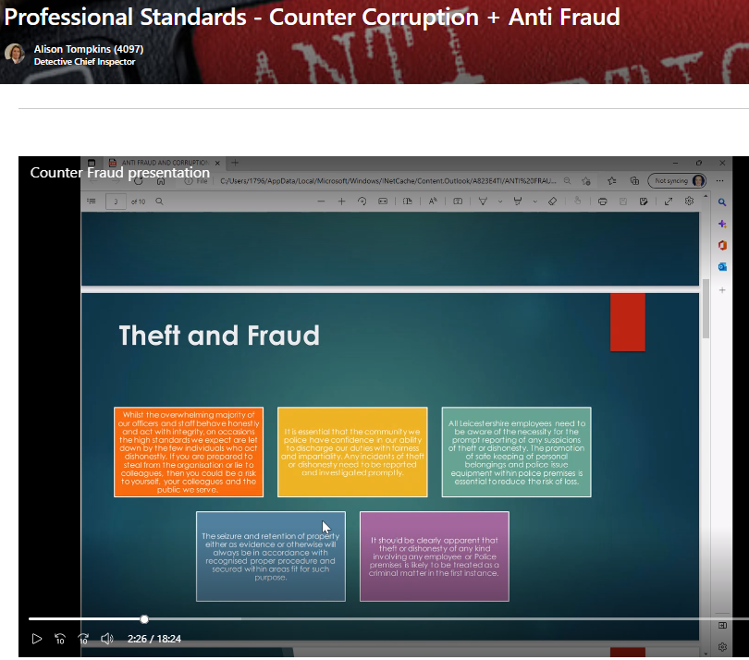  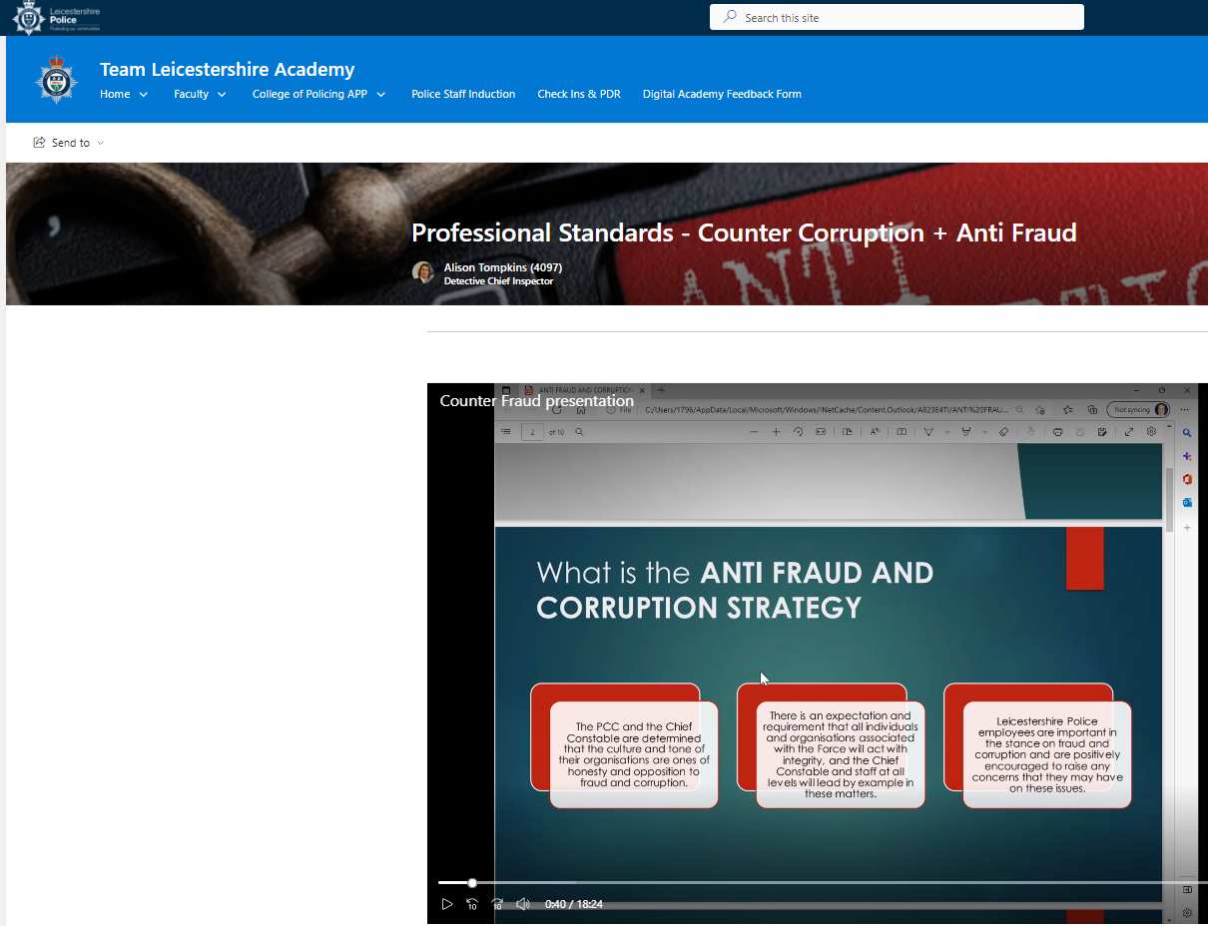  UPDATE July: It has been recognised that refreshed training is now required and this is being developed in conjunction with the Team Leicestershire Academy and the Training Commissioning Board.  UPDATE OCTOBER 2024  What has been achieved? Responses will be the same as Recommendation 1 above  The TLA Commissioning Board is unable to provide the assistance requested and proposed the above package as fit for purpose, which Mazar’s have indicated it is not fit for purpose. Further scoping of other training roll-out across the force has highlighted lower tech proposals similar to the role-out of the PVP packages or the use of a QR code at the end of the presentation which officers can scan and register their completion of the training.  The OPCC have completed the Anti-Fraud, Bribery and Corruption Policy. However, it needs to go to COT and the OPCC senior leadership team for consultation. Once both sides have approved it, it will go to the Corporate Governance Board CGB in December for formal sign off.  Once finalised a copy will be provided to JARAP.  What is left to complete?  This will now need to be published by the OPCC and shared across the force, with an internal media campaign – March 2025 target  Any barriers to completion?  None identified  Is the recommendation ‘proposed closed’? No remain open  If so, please provide sufficient narrative and evidence to support closure i.e. explain how the recommendation has been achieved and provide - documents, performance reports; anything that proves the recommendation has been met.  UPDATE April 2025  What has been achieved?  The anti-Fraud, Bribery and Corruption training has been sent to all directorate heads and followed up in January 2025 to all inspectors / staff equivalent to request they ensure their staff have com0pleted the training. To date, 1,477 have so far completed the training across the force. All details held in the CCU to monitor compliance.  The Joint Anti-Fraud, Bribery and Corruption Policy has been approved by the Corporate Governance Board CGB and an internal media campaign to all  An initial internal media message signposting the refreshed force policy; plus, a joint message from Head of PSD and OPCC CFO has been published across the force through the force intranet.  Anti-Fraud and Corruption Training – PowerPoint located within the TLA:  Internal intranet Link - ANTI FRAUD AND CORRUPTION STRATEGY TRAINING 2024 v2.pptx  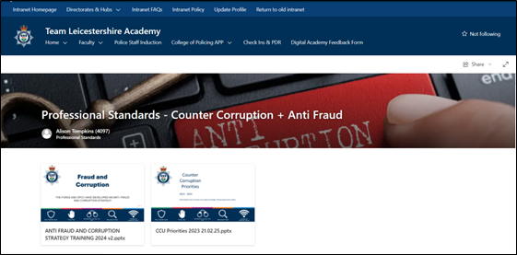  What is left to complete?  Monitor training delivery in terms of training completion rates – Determine and agree the level of compliance required in completing the training.  Any barriers to completion?  The training has not been labelled as mandatory due to the volume of training that comes out of the TLA which is mandatory.  Is the recommendation ‘proposed closed’? Not at this time. Once the level of compliance has been agreed, and the target compliance achieved the recommendation can be closed.
PARTNERSHIPS (Domestic Violence)  LIMITED ASSURANCE  June 2023 |  | 4.1 End of Contract Arrangements | High Priority Recommendation: The OPCC should ensure that, as laid out in the Commissioning Strategy 2021-2024, a final exit/lessons learned stage is conducted for expiring contracts. This should involve consideration of the effectiveness of the provider in achieving the objectives of the partnership, the performance of the provider in relation to general procurement criteria, and lessons learned assessment. An effective audit trail should be maintained for this process, including a final decision regarding any decisions to re-commission the incumbent provider.  Initial Management Response: Documents and process are in place but not currently used in existing contracts, going forward will plan in with providers at the start of all new contracts. The process will be implemented for expiring contracts and relevant dates will be set in place to plan for this.  Target - Implemented by May 2023 Charlotte Highcock – Commissioning Manager July 2024 Siobhan Peters – Director of Strategy, Partnerships & Commissioning OPCC LLR  UPDATE April 2025: Forvis/Mazars auditors revisited this recommendation in January 2025 with the following findings:  Implemented  Audit confirmed for the only service that has been decommissioned since the previous audit in June 2023, the ‘Target Hardening’ service with 24-7 Locks, that an exit interview was held and retained.  Details captured in the exit interview included contract performance data, successes of the contract, challenges to the contract and also general contract management notes. We were informed by the OPCC Director of Strategy,  Partnerships and Commissioning that all future decommissioned services will follow the same format.  Audit also reviewed an ‘Exit Strategy’ document for a domestic abuse project that is due to end in March 2025. Such Strategy outlines the steps to manage the exit of the project in order to minimise impact for all affected parties.  PROPOSED CLOSED
“ |  | 4.3 Compliance agreements | Medium Priority Recommendation: The OPCC should ensure that meeting and reporting requirements are clearly laid out in the contract/JWA. A standard terms schedule should be developed and applied to all partnership contracts, which include but not limited to; meeting requirements, contract management, exiting contract and arbitration for poor performance. The OPCC should maintain a risk register for any primary governance arrangements for all partnerships, which should be updated at each meeting and include seminal risks that would inhibit the stated objectives of the partnership or the wider objectives of the OPCC  Initial Management Response: As above relating to the contract/JWA. A new risk register started April 2023 for CARA contract in line with new contract term.  Target: June 2023 Target date change to Q3 2024 - Siobhan Peters Director of Strategy, Partnerships and Commissioning  Update June 2023: The commissioning risk register is updated each quarter, unless any urgent issues arise where a more dynamic response is required. The new 2023/2024 contracts have KPIs within them that are managed on a quarterly basis with monitoring information and contract management meetings. This process will continue for all new contracts going forward and we will have additional support to manage this with an external consultant who will ensure that systems and processes are implemented. - update provided by CI Nicola Streets as the Commissioning Manager is currently away.  UPDATE April 2025: Forvis/Mazars auditors revisited this recommendation in January 2025 with the following findings:  Implemented  Audit confirmed for a sample of two partnerships, CARA and LWA, that meeting requirements, contract management, exiting contract and arbitration for poor performance details are adequately captured within supporting contracts / agreements.  Audit confirmed that quarterly contract management s meetings are held for CARA and LWA as per supporting contracts / agreements and confirmed that risks are discussed at each meeting as a standing item agenda under ‘Risk Register – risks or issues to delivering the service’.  Located on the OPCC’s Strategic Risk Register is an overarching risk relating to the management of all partner relationships. Review of the register highlights that there are eight controls recorded against such risk.  PROPOSED CLOSED
“ |  | 4.4 Performance Monitoring | Medium Priority Recommendation: The OPCC should ensure that they are provided with regular, timely and comprehensive reports and updates regarding the performance of providers associated with their partnerships.  Initial Management Response: Performance framework due to be completed for commissioned services. Expectation of partners to be reviewed and clarified as above.  Target: May 2023 Target date change to Q3 2024 Target date change end of Q1 2024-25 To be ready for roll out next financial year 25/26 - Siobhan Peters Director of Strategy, Partnerships and Commissioning  UPDATE April 2025: Forvis/Mazars auditors revisited this recommendation in January 2025 with the following findings:  Implemented  Audit confirmed for a sample of two partnerships, CARA and LWA, that performance reports are submitted on a timely basis by providers in accordance with supporting contracts / agreements (quarterly for CARA and six-monthly for LWA).  In addition to the submission of performance reports, quarterly contract management meetings are held with all partnerships where performance of the provider is discussed as a standing item agenda.  PROPOSED CLOSED
ESTATES MANAGEMENT  SATISFACTORY ASSURANCE  July 2023 |  | 4.1 Stock condition surveys | Medium Priority Recommendation:  Stock condition surveys should be completed for the overdue buildings as soon as possible and survey completion dates should be agreed where not in place.  Initial Management Response: Agreed. The surveying of buildings got behind due to COVID. When this period was over, we lost our Electrical Engineer so still we were unable to carry out the surveys. This post is still vacant and will remain so for some months. When this post is filled the surveys will resume.  Target: Within 12 to 18 months [July 2024 – Jan 2025] Andrew Wroe - Head of Estates  UPDATE Oct 2024: Item 4.1 is on target for the department to catch up. The head of estates acknowledges that they have not caught up thus far and are currently two months behind with the surveys. However, the target date of January 2025 specified and agreed in last year’s audit should easily be achieved.  UPDATE April 2025:  What has been achieved?  Building biannual surveys are now up to date and programmed in for the next 6 months.  What is left to complete?  Nothing all surveys are up to date.  Any barriers to completion?  Insufficient staff  Is the recommendation ‘proposed closed’? If Yes, please provide evidence to support closure.  Yes, all surveys now up to date. This can be evidenced by looking at the completed reports.  PROPOSED CLOSED
PORTFOLIO MANAGEMENT  LIMITED ASSURANCE  May 2024 |  | 4. A lack of resource profile for the PMO, and for upcoming projects | Medium Priority Recommendation: The PMO should establish a resource profile against their own management requirements, and a profile for individual projects against a projected pipeline of upcoming projects.  Initial Management Response: We accept this and we will look into different methodologies to progress this.  Responsible Person: Sally Brooks - Project Manager / Suzi Nicholls - Project Manager  Target Date: 31st March 2025  UPDATE October 2024: This is still a work in progress, current resource profiles for ongoing projects are being collated, as well as projected upcoming projects as part of the Blueprint 2030 build – remain open  UPDATE April 2025: MS Project, HALO, SharePoint methodology explored and presented to PMO Programme Managers to track resources and discussed amongst Senior Management Team, and the preferred approach is to manage workloads with Project Managers via 121s, using the prioritisation matrix, conduct gated reviews, consider agile project management, collaborate with IT Project Managers for additional resources, fortnightly meetings with PMO and IT Programme Managers to discuss resource capacity.  The Blueprint 2026-27 has been signed off by the PCC and moving forward new requests for work will fall within the annual budget setting process and aligned with the following approach:  Business Case template will be completed across future programmes, including the capital programme.  The template collates details across the following areas:  - Vision Statement & Drivers for Change  - Aims & Scope (to include what’s in scope, what’s not, any constraints and assumptions)  - Aligned to Strategy (Priorities, Risks, FMS, Strategic Assessment, Police & Crime Plan, Regional / National)  - Anticipated Outcome & Benefits  - Proposed Options (including costs for recommended option)  - Interdependencies with Projects or BAU  - Key Stakeholders (informed and supportive of proposal, including public consultation)  - Estimated Resources for Defining & Delivery  PMO offers comprehensive support for prioritised new requests for work across the following areas:  Identification and Planning  The PMO offers Project planning support and prioritisation to ensure new work requests align with strategic objectives. They also offer Stakeholder Management, engaging with stakeholders to define project requirements and expectations.  Definition and Delivery  Standardised tools and templates to ensure consistency in project documentation and process. Regular reporting and monitoring of project performance to ensure it stays on track and meets its objectives. Follows project governance and project standards and practices. Provide Senior Management Team on the resource requirement for timely project delivery.  Closure and Benefit Realisation  Central tracking of cashable and non-cashable benefits. Assessment of successful outcomes through project closure reports.  The PMO also conducts the Force Management Statement FMS assessment, which includes a timely alignment to best support the force financial planning cycle.  PROPOSED CLOSED
 |  | 5. A lack of gap analysis to establish an understanding of available and missing skills | Medium Priority Recommendation: The PMO should conduct gap analysis of the available PMO skills and resources and create a skills matrix which identifies gaps.  Initial Management Response: We accept this and we will look to collate a skills matrix of all PMO staff.  Responsible Person: Sally Brooks - Project Manager / Suzi Nicholls - Project Manager  Target Date: 31st March 2025  UPDATE October 2024: A skills matrix has been created covering key activities and knowledge areas for the Change Team.  The matrix will provide an overview of skills across the team and their method of training to bridge any gaps.  Over the coming months this will be populated by Line Managers and ratified with staff during their regular 1-2-1 meetings to form an initial gap analysis and will then be tracked and updated through annual PDR meetings with the staff – remain open  (evidence: skills matrix excel spreadsheet provided for the October 2024 JARAP)  UPDATE April 2025: The skills matrix has now been fully populated by Line Managers and staff through 121 meetings and will be updated this way every 6 months.  The scores against each skill have been totalled to give a mean average. Any skills that fall below a score of 2.2 become the identified training needs for the team.  Avg Score RAG  <2.2 Lack of Skills – Training gap identified  2.3—2.6 Adequate skills- Training to be maintained  >2.7 Good Skills- Training is sufficient  This method has identified training needs, typically required within Project Manager roles in the following areas:  Areas to be covered in the quarter.  Information Management – DPIA completion, Information sharing and Information Risk Assessment – Workshop has been arranged for 3rd Feb 25. Subject Matter experts will be providing input and scenario based completion of DPIA also included.  Procurement Knowledge – Tenure stages and Single Source Dispensation –A workshop to be arranged with Procurement lead and Project Managers.  Direct Line Management- Force wide leadership programme has been created by Team Leicestershire Academy (TLA) and all staff have enrolled. The programme is available for all Leicestershire police employees with tailored modules for first line leaders, mid-level leaders and senior leaders, completion of this has also been included in PMO staff Personal Development Review (PDR) as an objective.  Next Quarter  IT Infrastructure/platforms knowledge.  Use of Microsoft lists.  PROPOSED CLOSED
 |  | 6. A lack of standardised tools and templates to act as procedural guidance for project managers | Low Priority Recommendations:  1. The PMO should complete the suite of best practice portfolio management templates and tools and share them to the wider team.  2. The PMO should complete their suite of how-to-guides, which act as practical steps in the implementation of key processes.  Initial Management Response: We are gathering forms/templates together to add to our suite of documents which will be published on our SharePoint site to complete our full suite of documents.  Responsible Person: Sally Brooks - Project Manager / Suzi Nicholls - Project Manager  Target Date: 31st March 2025  UPDATE October 2024: Further templates have been created and aligned to Praxis, Project Closure Reports and Change Reports are currently being trialled.  Surveys are being developed to understand how successful the PMO is, this will inform a set of KPIs.  Additionally, we have a dedicated resource to continually develop the PMO SharePoint site – remain open  (Evidence: Project Closure Report Draft, Change Report Draft provided for the October 2024 JARAP)  UPDATE January 2025:  Change Control Report & Project Closure report finalised and now in use to complement existing templates of Outline Business Case and Full Business Case.  How to guidance created and published on PMO SharePoint site for: Stakeholder Management, Risk Management, Benefit Management and Lesson Learned how to Guidance has also been created n published. Risk Management how to guidance has been refreshed and published on our SharePoint site.  PROPOSED CLOSED
MEDIUM TERM FINANCIAL PLAN  SUBSTANTIAL ASSURANCE  May 2024 |  | 1. Savings Plan | Low Priority Recommendations 1: A longer-term efficiency plan should be developed at the earliest opportunity to address future forecasted budget deficits.  Initial Management Response: This recommendation is referenced to the September 2021 audit. At the time the MTFP was in a balanced position and hence the need for an efficiency plan reduced.  However, given the changing financial landscape A Budget Deficit (Sustainability) Plan is now in place. During 2023 the following papers were presented to the Corporate Governance Board:  - 21/06/2023 – Efficiency Savings Report – setting out approach  - Office of the Police and Crime Commissioner for Leicestershire and Leicestershire Police – Medium Term Financial Planning (09.23/24) Internal Audit Report Page 7  - 11/12/2023 – Budget Efficiency Report  - 24/01/2024 – Operational Report, including Efficiency Plan  The plan has been developed further since January 2024 and the latest copy of the plan is being presented to CGB in May 2024. The plan covers 2023/24 through to 2025/26.  Responsible Person: Michaela Kerr Deputy Chief Constable / Paul Dawkins – Assistant Chief Officer (Resources)  Target Date: Ongoing  UPDATE October 2024:  What has been achieved?  Revised Budget Sustainability Plan submitted to CGB in July 2024. The budget is on track to balance during 2024/25 and over achieve savings target by £4m plus in preparation for 2025/26.  What is left to complete?  Ongoing delivery of savings through to year end and development of sustainable savings plan for 2025/26 and beyond.  Any barriers to completion?  Not during 2024/25 but challenges remain for 2025/26 which largely depend on the outcome of the Home Office Settlement for policing in England & Wales to be announced in December 2024.  Is the recommendation ‘proposed closed’? No leave open  If so, please provide sufficient narrative and evidence to support closure i.e. explain how the recommendation has been achieved and provide - documents, performance reports; anything that proves the recommendation has been met.  UPDATE April 2025:  The ACO Finance has drafted an updated balanced budget report in relation to this recommendation for the next Corporate Governance Board CGB that convenes on the 6th May.  Once the Chief Constable and Police Crime Commissioner have approved and signed the budget report off a copy will be provided. A verbal update is to be provided to the panel at the forthcoming JARAP meeting on the 16th May and in essence the update will allow the respective recommendation to be proposed closed Paul Dawkins - Assistant Chief Officer (Finance & Resources)  PROPOSED CLOSED
 |  | 2. Budget Holder Training | Low Priority Recommendation:  1. The Force should implement a formal programme of training for budget holders, including refresher training.  2. A training needs analysis should be completed to ensure that the right level of training is provided to those who need it.  Initial Management Response: Financial awareness training is now be delivered as part of the 3-layer Leadership Training.  The Force has also joined the CIPFA AFEPIII programme which gives access to training courses.  A training needs analysis will be developed for new budget holders to identify gaps in knowledge that require additional training support.  Responsible Person: Marie Watts Strategic Management Accountant  Target Date: 31st December 2024  UPDATE October 2024:  What has been achieved?  The training needs analysis process has commenced and the data is being collated in relation to new budget holders.  What is left to complete?  - Data collation and analysis  - Development of a plan based on the training needs analysis.  Any barriers to completion?  None identified.  Is the recommendation ‘proposed closed’? No leave open  If so, please provide sufficient narrative and evidence to support closure i.e. explain how the recommendation has been achieved and provide - documents, performance reports; anything that proves the recommendation has been met.  UPDATE April 2025:  What has been achieved?  The lead has met with the force Change Team to look at examples of training needs analysis, and capture ideas which are to be put into practice. Unfortunately, due to workload pressures the lead has not been able to progress this as far as wished. Now that other crucial financial tasks are completed (outturn) the lead is focussing on this piece of work and aims to complete it by the end of May.  What is left to complete?  - Data collation and analysis  - Development of a plan based on the training needs analysis.  Any barriers to completion?  The barriers to completion thus far have been other pressures, including budget setting in December and January and now outturn.  Is the recommendation ‘proposed closed’? No remain open  If so, please provide sufficient narrative and evidence to support closure i.e. explain how the recommendation has been achieved and provide - documents, performance reports; anything that proves the recommendation has been met.
OCCUPTATIONAL HEALTH  SUBSTANTIAL ASSURANCE  June 2024 |  | 1. Presenting KPIs after the implementation of Cority | Low Priority Recommendation: The Unit should consider how the new source data from the clinical management system can be presented. If new KPIs are necessary, these should be reported to Senior Management.  Initial Management Response: Cority data is being worked on (new system) and there have been several discussions with the PowerBi and data analyst team about how best to present this data to future boards.  Responsible Person: Tim Ellis – Head of Occupational Health and Wellbeing  Target Date: January 2025  UPDATE October:  What has been achieved?  Cority is now producing data.  What is left to complete?  Work ongoing with PowerBi and business analyst team to get this into format required for specific boards  Any barriers to completion?  Getting business analyst support has been challenging but progress has been made in this area.  Is the recommendation ‘proposed closed’? No remains open – looking to submit evidence to support closure in the new year.  UPDATE April 2025: Lead unwell at the time of reporting
 |  | 2. Gap Analysis for Target Operating Model and Action Plan | Low Priority Recommendation: The Force should consider conducting a Gap Analysis between their current operating standards and the updated Oscar Kilo Enhanced Standards (Level 2) and develop an action plan to ensure compliance.  Initial Management Response: As with all forces, the Oscar Kilo team have now put the new standards into the Blue Light Wellbeing Framework (replacing the previous Foundation standards).  I agree we need a gap analysis exercise conducting against the new standards. The HMICFRS inspection due shortly will include the Foundation standards, so after this we will be focusing on the new standards.  Responsible Person: Tim Ellis – Head of Occupational Health and Wellbeing  Target Date: January 2025  UPDATE October:  What has been achieved?  Oscar Kilo & the Blue Light Wellbeing Framework (BLWF) - a gap analysis with RAG rating has been completed and reported to People Board.  What is left to complete?  Specific areas of development have been allocated to key contacts to take forward.  Any barriers to completion?  Key contacts are having to be chased for their updates.  As discussed with HMI inspectors this is part of ongoing process improvement and not task and finish items. This was agreed at People Board and will continue to be monitored / reported on.  Is the recommendation ‘proposed closed’? No remains open – looking to submit evidence to support closure in the new year.  UPDATE April 2025: Lead unwell at the time of reporting
COUNTER FRAUD and WHISTLEBLOWING  SUBSTANTIAL ASSURANCE  June 2024 |  | 1. Fraud Training | High Priority Recommendation: The Force should carry out a training needs analysis to establish which areas of the organisation have a higher risk and fraud and need specific / tailored training.  The Force should ensure that there is an appropriate provision of training to meet the needs of the organisation highlighted from the training needs analysis.  The delivery of all training should be monitored centrally for its effectiveness and completion rates and regularly reviewed to ensure it is meeting the needs of the organisation.  Initial Management Response: Engaged with Change Team to assist in this area.  Accept that the current training package needs updating. This will allow for self-updating from within the department and will work with IT to make this auditable.  Responsible Person: D/Supt Alison Tompkins Chris Baker, Head of Professional Standards and D/Insp Esther Scott  Target Date: Revised to August 2025 31st March 2025  UPDATE OCTOBER 2024  What has been achieved?  The TLA Commissioning Board is unable to provide the assistance requested and proposed the above package as fit for purpose, which Mazar’s have indicated it is not fit for purpose. Further scoping of other training roll-out across the force has highlighted lower tech proposals similar to the role-out of the PVP packages or the use of a QR code at the end of the presentation which officers can scan and register their completion of the training.  The OPCC have completed the Anti-Fraud, Bribery and Corruption Policy. However, it needs to go to COT and the OPCC senior leadership team for consultation. Once both sides have approved it, it will go to the Corporate Governance Board CGB in December for formal sign off.  Once finalised a copy will be provided to JARAP.  What is left to complete?  This will now need to be published by the OPCC and shared across the force, with an internal media campaign – March 2025 target  Any barriers to completion?  None identified  Is the recommendation ‘proposed closed’? No remain open  See update for 4.3 Lack of Fraud Training on pages 24 – 26 above.
 |  | 2. Fraud Risks and Registers | Medium Priority Recommendation: The Force should develop a risk register system for fraud specific  risks separate from its departmental and strategic risk registers.  Once implemented, fraud risks should be identified and recorded on the fraud risk register and action plans implemented to mitigate risks, which are then reviewed on a regular basis.  Initial Management Response: Agree to instigate a risk register in CCU specifically around the risk area of Theft and Fraud, which will lay out risk, relevant department, mitigating controls and a review date. This will form part of the 4P development plan already in existence for Theft and Fraud within CCU.  Responsible Person: D/Supt Alison Tompkins Chris Baker, Head of Professional Standards and D/Insp Esther Scott  Target Date: 31st March 2025 Revised Target – End of August 2025  UPDATE July 2024: Matt Jones (Health and Safety and Risk Lead) - The risk register will sit on the force force risk register system Keto.  Actions required:  - To identify what policies are already in place that reflect mitigation around theft and fraud.  - To include 6 monthly reviews and document policy adhered to within Counter Corruption Unit CCU Risk Plan  - Within these policies to highlight new risks and what is to be done to mitigate against them. These will be added within the training package when rolled out.  UPDATE October 2024:  What has been achieved?  The Anti-Fraud and Theft Risk to be registered on Keto and actions to mitigate the risks will sit with the Counter Corruption Unit CCU PSD.  What is left to complete?  Every business area is to add into their business policy / procedure a statement on how they will identify fraud and theft, what they can do to mitigate it and reporting mechanism to the CCU PSD.  Any barriers to completion?  This has not been agreed by the heads of directorates and will need to be brought to the most appropriate meeting to be agreed.  Is the recommendation ‘proposed closed’? No remains open  UPDATE April 2025:  What has been achieved?  The force had initially looked at changing all force policies to include a section on anti- fraud/corruption, however the reality is this is not achievable. There are so many policies and procedures in total; some of which will pose a higher risk than others in terms of the potential for fraud and theft.  Now that those risk relevant areas of business have been identified the owners are to be provided with a set approach, template to insert into policy/procedure regarding guidance and considerations necessary regarding Anti-Fraud, Theft and Corruption. This will ensure a consistent approach in both supporting business owners and understanding the potential risks involved in the area of business concerned.  Departments identified are as follows:  - Procurement  - Purchasing  - Finance  - Property  - Estates  - Resource Planning  - Asset Management (IT)  What is left to complete?  The development of the set approach/template to share alongside the newly approved Joint Anti-Fraud, Bribery and Corruption Policy to the identified departments.  This is a joint development going forward between the force Professional Standards Department PPSD and the force Risk Unit.  Any barriers to completion? None  Is the recommendation proposed closed? If so, please provide sufficient narrative and evidence to support closure. No remains open.
 |  | 3. Recording of whistleblowing allegations | Medium Priority Recommendation: It should be ensured that the significant events logs within progress logs are completed fully to ensure that the investigations undertaken and resolution are clearly recorded. The initial response sent to the whistle-blower following a whistleblowing report being made should clearly include the four points set out in the Whistle-blowers’ Procedure e.g. indication of how the matter will be dealt with.  Initial Management Response: Accept that the current training package needs updating. This will allow for self-updating from within the department and will work with IT to make this auditable.  Responsible Person: D/Supt Alison Tompkins Chris Baker, Head of Professional Standards and D/Insp Esther Scott  Target Date: 31st March 2025  UPDATE July 2024: This is housekeeping within the CCU and easily achieved with more robust line manager reviews.  This is referring predominately to Bad Apple (BA). Only the supervisors in CCU respond to BA and a new practice adopted to satisfy the requirements as Mazar's have classified the reports as Whistle-blowers.  UPDATE October 2024:  What has been achieved? See update re training package  What is left to complete?  Is the recommendation proposed closed? No remains open  UPDATE April 2025:  What has been achieved?  Internal CCU processes have been updated to ensure the four points set out within the Whistle-blower Policy are adhered to. Bad Apple is not a forum for a protected disclosure according to the policy.  What is left to complete? Nothing N/A  Any barriers to completion? None  Is the recommendation proposed closed? If so, please provide sufficient evidence to support closure i.e. explain how the recommendation has been achieved and provide documents, performance reports and anything that proves the recommendation has been met.  Yes - The force Whistle-blowers Policy is current and available on the PSD intranet website.  Internal processes with the head of PSD and within the CCU are in place to manage any protected disclosure. This has been tested in late 2024 with the disclosure and resolution documented appropriately.  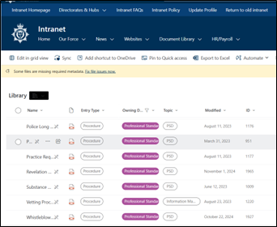  PROPOSED CLOSED
 |  | 4. Anti-Fraud and Corruption Strategy | Medium Priority Recommendation: The Force and OPCC should produce and publish a separate Anti-Fraud and Corruption Strategy.  Initial Management Response: Agree that there is not currently a Force policy on Anti-Fraud. This will form part of the 4P development plan already in existence for Theft and Fraud within  CCU.  Responsible Person: D/Supt Alison Tompkins Chris Baker, Head of Professional Standards and D/Insp Esther Scott  Target Date: 31st March 2025  UPDATE July 2024: Work in progress between the CCU DI and the OPCC Chief Finance Officer – Kira Hughes. Mazars suggested Lincolnshire Police and the OPCC had a good policy in place. A copy has been obtained and reviewed to support development of the Leicestershire OPCC and Police joint policy going forward.  UPDATE October 2024:  What has been achieved?  The policy has been revised by both OPCC CFO and DI CCU. The OPCC have completed the Anti-Fraud, Bribery and Corruption Policy. However, it needs to go to COT and the OPCC senior leadership team for consultation. Once both sides have approved it, it will go to the Corporate Governance Board CGB in December for formal sign off.  Once finalised a copy will be provided to JARAP.  What is left to complete?  Once considered and finally agreed the policy will need to be published by the OPCC and shared across the force, with an internal media campaign.  Any barriers to completion?  None identified  Is the recommendation ‘proposed closed’?  Not at this time – to remain open  If so, please provide sufficient narrative and evidence to support closure i.e. explain how the recommendation has been achieved and provide - documents, performance reports; anything that proves the recommendation has been met.  UPDATE APRIL2025:  What has been achieved?  The policy has been revised by both OPCC Chief Financial Officer CFO and the DI Counter Corruption Unit CCU within the force Professional Standards Department PSD.  The Joint Anti-fraud, bribery and corruption policy was agreed and signed off at the Corporate Governance Board CGB in March 2025. It is tabled to be reported to JARAP at the next meeting in May – Agenda item 13 Fraud and Corruption Strategy.  What is left to complete? Nothing N/A  Any barriers to completion? None N/A  Is the recommendation ‘proposed closed’? Yes, the Anti-Fraud, Bribery and Corruption Policy has been created.  PROPOSED CLOSED
ASSET MANAGEMENT  SUBSTANTIAL OPINION  August 2024 |  | 1. Functionality of Asset Register Software | Low Priority Recommendation: The Force should investigate upgrades or alternative systems for Asset Management, looking to resolve user performance issues and potentially providing improved features.  Initial Management Response: The force has invested in a new IT Service Management tool – one of its functions is asset management. Once this tool is deployed – one of the next phases of development will be to move assets of the Equitrax system – making that redundant. The new ITSM Tool can link into various information sources to improve asset awareness. GPS tracking of some assets is currently done outside of the Asset Management system because of the secure nature of that information – this specifically applies to radios. The capability to track smartphones and laptops with the 365 Intune tool will be explored in an R&D project during 24/25. Depending on results, rollout or further investment in tools or capabilities will be explored in 24/25. This will require this package of work to go through organisational governance processes to develop the requirement, attract funding and resources to deliver.  Responsible Person: Andy Elliott – Interim Head of IT / CTO  Target Date: 31st March 2025 3rd Qtr 2025-26  UPDATE April 2025:  What has been achieved?  The transition to HALO has begun for our Monitors, Docks, Desktops and Laptops. Processes are currently in development to ensure we are controlling our laptops and desktops correctly before fully migrating this over.  What is left to complete?  Essentially, everything is moving into Halo but not as quickly as expected. A really positive development in terms of adding value is that the force is starting to exploit the potential within Halo far more which is positive and the right thing to do.  The next phase in transition will be our smart phone and sim card assets, followed by our Body Worn Video assets. Discussions with the forces BWV provider will commence soon as there are interdependencies which will need to be worked through to allow the cameras to be booked out.  The final phase will be Airwave radios. Development of a pool booking out process will need to be worked through on HALO before these assets can be fully managed.  Any barriers to completion?  The main barrier to completion is resourcing and capacity. Progress is being made transitioning to Halo but the team are also re-modelling Halo for many other functions, including managing projects therefore the team are carefully defining, designing and building new functionality in Halo to manage IT work, process and procedures.  Is the recommendation proposed closed? If so, please provide sufficient narrative and evidence to support closure. No remains open.  Good progress is being made and asset management is being transitioned across however, it is unlikely to be completed before the Autumn therefore this should remain open for now until it is completed, fully tested and transitioned to BAU. Andy Elliott – Interim Head of IT / CTO
STAFF RETENTION  MODERATE OPINION  September 2024 |  | 1.Multiple Risk Scoring Methodologies | Medium Priority Recommendation: The Force and OPCC should update all risk documentation to ensure that methodology sections are consistent. Additionally, the Force and OPCC should determine their risk appetite, specifically what scores they no longer wish to tolerate and require action, providing a risk tolerance line.  Initial Management Response:  1. While the majority of information contained within the papers shared was current and consistent, there was some legacy information linked to a previous risk management system that has now been removed. Future reporting will use extracts from KETO obtained prior to the SERB meeting and amended registers following SERB meetings will be shared with the Health & Safety Team to update KETO and avoid separate registers.  2. The risks without mitigating controls have been reviewed and confirmed that these are in place, however there is an issue with the system in reporting these controls as they do not have a description against them. The Health & Safety Team will add descriptions to all controls and ensure that this is a required field when adding new controls in KETO. It is noted that the OPCC and Force have agreed not to implement a risk tolerance line as part of their risk management policies.  Responsible Person: Matthew Jones – Head of Safety, Sustainability and Risk  Target Date: 31st October 2024  UPDATE April 2025:  What has been achieved?  The force has decided not to have a tolerance line as this does not have any benefit.  The risk policy and procedure is clear and there is a consistent methodology.  Control descriptions have been added to all controls.  What is left to complete?  Nothing  Any barriers to completion?  None  Is the recommendation ‘proposed closed’? If Yes, please provide evidence to support closure.  Yes, propose closed.  Keto is being used as the main risk management system.  PROPOSED CLOSED
 |  | 2. Incomplete Delivery Plans | Low Priority Recommendation: The Force should prioritise the completion and update of the HR Retention Strategy and Operational Delivery Plan, so that it includes all required information (i.e. responsible persons, measures of success and RAG ratings)  Responsible Person: Kathryn Eaton - Head of Human Resources and Amy Coombe - Project Manager  Target Date: 30th September 2024  UPDATE April 2025:  What has been achieved?  The Operational Delivery Plan template has recently been amended at Force level and the HR one has been transposed and adjusted to align to this format. HR Operational Delivery Plan embedded here:  What is left to complete?  Nothing  Any barriers to completion?  None  Is the recommendation ‘proposed closed’? If Yes, please provide evidence to support closure.  Yes, propose closed.  PROPOSED CLOSED
BUSINESS CONTINUITY  LIMITED OPINION  October 2024 |  | 1. Business Continuity Plan Testing | High Priority Recommendation: The Business Continuity Policy and Procedure should be updated to define how often testing should be undertaken for departmental business continuity plans. Heads of Department / Plan Owners should then develop a schedule of testing for their business continuity plans and undertake testing in accordance with the schedule, and the outcomes of testing should be reported to an appropriate board or committee. The Force should ensure that it develops business continuity management competencies within the Specialist Support Department through additional training.  Initial Management Response: Leicestershire Police lost some key personnel who were trained in Business Continuity. Two members of staff are due to receive training in business continuity allowing us to have the competency to complete this action.  Responsible Person: Matthew Jones – Head of Safety, Sustainability and Risk  Target Date: 31st March 2025  UPDATE April 2025:  What has been achieved?  Completed, and documents within Business Continuity BC Procedure.  What is left to complete?  Nothing – ratified at SORB  Any barriers to completion?  None  Is the recommendation ‘proposed closed’? If Yes, please provide evidence to support closure.  Yes, proposed closed.  Business Continuity Policy: Business Continuity Procedure:  PROPOSED CLOSED
 |  | 2. Outdated Business Continuity Plans | Medium Priority Recommendation: Plan Owners for the overdue business continuity plans should ensure that a review is undertaken as a priority.  The Force should set a deadline for reviewing all overdue plans for Plan Owners to be held accountable against.  Initial Management Response: This action is agreed.  Responsible Person: Matthew Jones – Head of Safety, Sustainability and Risk  Target Date: 31st March 2025  UPDATE April 2025:  What has been achieved?  All owners have been asked to update plans in November 2024.  What is left to complete?  We have created a new Business Continuity BC Plan template, so the central BC team are currently updating these in conjunction with departments; but with a focus on accuracy and quality rather than just having a new review date. The focus has been on HQ, especially AIU, Digital Hub, IT and CMD as these are the most affected by our biggest strategic risk.  Any barriers to completion?  Time – there is significant work to support all departments and there is currently one member of staff acting as BC Advisor.  Is the recommendation ‘proposed closed’? If Yes, please provide evidence to support closure.  No.
 |  | 3. Contingency Plan Testing | Medium Priority Recommendation: The Force should review the prioritisation of its contingency plans to determine the priority levels, and if a plan is low priority this should be documented with a clear rationale.  The Force should establish a minimum testing frequency even for its low priority contingency plans to ensure periodic review and validation of the plan.  A formal record-keeping process should be implemented for plans which are tested regularly as part of daily business, such as the Firearms Incidents plan.  Initial Management Response: Whilst all BC plans were tested during COVID19 and a recent nation-wide power outage activity, as well as all plans tested twice per year in fire drills, we agree to this action and once we have qualified staff (being trained November 2024) we will coordinate a BC training schedule.  Responsible Person: Matthew Jones – Head of Safety, Sustainability and Risk  Target Date: 31st March 2025  UPDATE April 2025:  What has been achieved?  It has been agreed that all plans will be reviewed annually, unless deemed higher priority. A list of these is being drafted.  What is left to complete?  A list of priority BC plans.  Any barriers to completion?  Time.  Is the recommendation ‘proposed closed’? If Yes, please provide evidence to support closure.  No
 |  | 4. Multi Agency Business Continuity Working Group | Low Priority Recommendation: A representative from the Force should attend the quarterly Multi-Agency Business Continuity Working Group.  Initial Management Response: . This is action is agreed and we will be in a position to attend the group once we have 2 individuals trained in November 2024.  Responsible Person: Matthew Jones – Head of Safety, Sustainability and Risk  Target Date: 31st December 2024  UPDATE April 2025:  What has been achieved?  Completed - the Business Continuity BC Advisor is now attending the quarterly Multi-Agency Business Continuity Working Group meetings.  What is left to complete?  None  Any barriers to completion?  None  Is the recommendation ‘proposed closed’? If Yes, please provide evidence to support closure.  Yes. Evidenced by the BC Advisor attending the meetings.  PROPOSED CLOSED
OPCC COMMUNITY ENGAGEMENT  MODERATE OPINION  October 2024 |  | - Develop annual Communications Plan. | Medium Priority Recommendation: The OPCC should develop an annual communication plan which includes the  following:  - Main objectives and specific outcomes that the communication plan aims to achieve.  - Key themes / projects for engagement throughout the year.  - Timelines for communication activities.  - Financial resources allocated to each key activity.  - Mechanisms to track the progress of communication activities and evaluate effectiveness.  - Joint communication activities between the Force and OPCC throughout the year.  The plan should be reviewed and updated regularly to ensure it remains relevant and effective, allowing the OPCC to respond to changes in stakeholder availability and unforeseen events.  Responsible Person: Stephen Powell – Head of Communications and Engagement  Target Date: 31st December 2024  UPDATE April 2025:  What has been completed?  The following briefing paper from the Head of Communications and Engagement to the OPCC Chief Executive outlines how each of the recommendations have been addressed [Appendix copy provided to JARAP]  What is left to complete?  None  Any barriers to completion?  None  Is the recommendation ‘proposed closed’? If Yes, please provide evidence to support closure.  Yes. Copies of linked documents in the briefing requested  - Planner – Comms:  - 2024-2028 Comms Overview:  - Leicester, Leicestershire and Rutland PCC Engagement Tracker 2024-28: See separate doc attached  - PCC Engagements Map 2024-2028:  - Community Day Actions and Themes Tracker 2025  PROPOSED CLOSED
 |  | - Standardised procedures and Training sessions | Low Priority Recommendation: The OPCC should:  - Design clear and standardised procedures for documenting community visits, specifying what information must be recorded for each visit.  - Conduct training sessions with the relevant staff members to ensure there is a clear understanding of the importance of complete and accurate data entry.  - Periodically review the tracker to ensure that all required fields for each visit are adequately filled out. As part of this review the OPPC could also verify whether the current status of actions is correctly reflected within the tracker.  Responsible Person: Stephen Powell – Head of Communications and Engagement  Target Date: 31st December 2024.  UPDATE April 2025: Please see above collective response at recommendation 1  PROPOSED CLOSED
 |  | - Communication Protocol reviewed | Low Priority Recommendation:  a. The OPCC should ensure that moving forward, it's Communication Protocol OPCC / Force is reviewed and approved in line with the review timescale.  Responsible Person: Sallie Blair Consultant (Better Times)Stephen Powell – Head of Communications and Engagement  Target Date: 31st October 2024  UPDATE April 2025: Please see above collective response at recommendation 1  b. The OPCC should implement a review schedule document which details the last and next review dates, review frequency and individuals responsible for reviewing and approving each policy. The schedule should be reviewed by Management at a regular frequency to ensure policies remain up to date and in line with current practice.  Responsible Person: Nimisha Padhiar – Policy and Compliance Officer OPCC  Target Date: 31st December 2024  UPDATE April 2025: Please see above collective response at recommendation 1  PROPOSED CLOSED
SEIZED PROPERTY  MODERATE OPINION  December 2024 |  | - Guidance for Officers/staff | Medium Priority Recommendation: The Force should reinforce to Officers and Staff the importance of carefully updating NICHE in a timely manner to provide a full audit trail of exhibit movements.  The Force should explore potential digital avenues, such as scanning property, to record exhibit movements when checked in and out by Officers and Staff; such approach would enable an immediate and accurate update as to the current location of evidence.  Responsible Person: Amie Peplow – Evidence Manager  Target Date: 31st July 2025  UPDATE April 2025:  What has been completed?  The breakdown of the officer and staff’s responsibilities are detailed within the Evidential Property Procedure document.  Using the data collected from the Temp Store audits and the non-compliance sheet, posters will be placed on each of the temp store doors. The guidance will change at regular intervals when a different theme is identified.  Performance Managers will be sent the audit findings from the temp stores. The Performance Managers will address the issues with their officers and staff. In additional to this Performance managers will reinforce the message.  The Head of Business Change is supportive of the new mobile app that will provide the digital solution that is being recommended.  What is left to complete? Nothing  Barriers to completion? None  Is the recommendation proposed closed? YES – As above, the recommendation has been completed in full.  PROPOSED CLOSED
 |  | - Records management | Medium Priority Recommendation: The Force should investigate the possibility of updating the NICHE system to adequately record all ‘sub-locations’ within the Digital Data Hub Temporary Store, thus aligning such record with all other Temporary Stores.  The Force should remind Digital Data Hub Staff the importance of updating the NICHE system when removing items for investigation, as NICHE is the main evidential property record maintained for all seized property handled by Leicestershire Police.  Responsible Person: Amie Peplow – Evidence Manager and DI Tom Brenton  Target Date: 31st May 2025  UPDATE April 2025:  What has been completed?  The process of using the sub-locations within the Digital Hub has been agreed and they have been created within Niche.  What is left to complete?  20th May 2025 – full audit of the Digital Hub store by the EPAT. The sub-locations will be introduced during the audit where the auditors will scan the exhibits to the new locations.  Digital Hub Manager to communicate the change in process and remind their staff that they must update Niche when depositing or removing items from the store.  Barriers to completion? None  Is the recommendation proposed closed? No
 |  | - Property Management procedure update | Low Priority Recommendation: The Force should update their Property Management Procedure to reflect current working practices with respect to the RTO process, this will ensure staff are clearly aware of their roles and responsibilities and ensure a consistent approach is adopted.  Responsible Person: Amie Peplow – Evidence Manager  Target Date: 31st December 2024  UPDATE April 2025:  What has been completed?  Section 4.7 Returning Items to Owner of the Evidential Property Procedure accurately describes the process that is required. NPA Deputies have also been sent clear guidance to share with the LSTO’s and the PCSO’s who provide cover.  What if anything is left to complete?  Nothing  Barriers to completion?  None  Is the recommendation proposed closed? YES – As above, the recommendation has been completed in full.  PROPOSED CLOSED
 |  | - Enhance security | Low Priority Recommendation: The Force should enhance security measures with respect to the SCIU Temporary Store, by either updating access into the Store itself via swipe card aligning it with other Temporary Stores, or storing the physical key into the Store in a more secure manner.  Responsible Person: DI Steve Kilsby SCIU [update from DI Kilsby, however DI Parminder Dhillon is now head of SCIU]  Target Date: 30th November 2024  UPDATE April 2025:  What has been completed?  The store access has been reviewed in full. There is now a dedicated, locked safe in the FCI office and a sign out book. This is all being led and checked by the FCI Sgts on a regular basis.  In addition, the SCIU store is subject to regular, enhanced internal EPAC audit regime which is fed back directly to the head of dept (DI) for action.  What if anything is left to complete?  The security of the store is going to be enhanced even further with the agreement of a capital building project to refurbish the RPU garage area. This proposal was agreed at exec in 2023 and is awaiting the building works to start. This will include complete X-plan and electronic access to the refurbished store, which will bring it in line with other areas.  Barriers to completion?  None at this time - TBC with estates on when the works will be completed.  Is the recommendation proposed closed? YES - As above, all recommendations have been implemented.  PROPOSED CLOSED
 |  | - Secure storage and accurate labelling | Low Priority Recommendation: The Force should remind OBIs of their responsibilities to securely store and accurately label all exhibits upon initial seizure. Non-compliance should be corrected at the next earliest opportunity (when storing the property) with the offending OBI identified and addressed appropriately.  Responsible Person: Amie Peplow – Evidence Manager  Target Date: 31st March 2025  UPDATE April 2025:  What has been completed?  Posters are rotated within the Temp Stores with the key messages.  Non-compliance is addressed directly with the OBI via an email.  The Performance Managers will be sent the audit findings from the temp stores. The Performance Managers will address the issues with their officers and staff. In additional to this Performance Managers will remind the OBIs of their responsibilities.  What if anything is left to complete? Nothing  Barriers to completion? None  Is the recommendation proposed closed? YES – As above. The recommendation has been completed in full.  PROPOSED CLOSED
CORE FINANCIALS  SUBSTANTIAL OPINION  March 2025 |  | - Audit Trail | Low Priority Recommendation: The Force should keep sufficient audit trail of debt management actions to ensure aged debts are appropriately chased in line with the Credit Control Policy.  Responsible Person: Jane Timms Financial Services Manager  Target Date: 28th February 2025  UPDATE April 2025:  What has been completed?  The team have been given refresher training on the Credit Control Policy and Debtor Management is specifically included within the daily team meetings.  New debts over 28 days are divided out between the team and they contact the customer chasing payments and report back at the weekly team meeting; where there are any concerns, then these are discussed to establish what further actions could be taken.  The actions taken have considerably reduced the amount of debts moving into the over 60 days category.  This also forms part of the teams monthly Performance reporting which is reviewed by the Financial Management Team the departmental head and ACO Finance.  The processes adopted by the department have also been taken on board by EMSOU, albeit EMSOU chase their own debtors, the force team link in with them and the Debtor information is provided each month.  What if anything is left to complete?  Nothing N/A  Barriers to completion?  Nothing N/A  Is the recommendation proposed closed? Yes  If yes, please provide sufficient narrative and evidence to support closure.  PROPOSED CLOSED
DATA QUALITY  LIMITED OPINION  April 2025 |  | 1. Project plan data quality improvement | High Priority Recommendation: The Force should:  - Perform an exercise to identify and agree all the key themes and areas that require improvement with respect to data quality.  - Create an overall programme of work or delivery plan once the above exercise has been performed.  - Consider creating individual operational workstreams, to support the delivery of the programme or plan, for key areas of work or systems.  - Establish and implement robust governance, monitoring, and reporting processes for the overall programme or delivery plan and key workstreams at the Force.  Responsible Person: C/Insp Dave Adams – Policy and Compliance  Target Date: 1st August 2025  UPDATE April 2025: Recently published audit report – update will be provided for the next panel meeting
 |  | - Access controls | Medium Priority Recommendation: The Force should work with the Niche national and regional working groups, in  collaboration with other Forces in the region, to assess the feasibility of implementing segregation of duty and access controls to ensure Officers cannot finalise incidents opened by them.  If this is not possible, the Force should perform regular and routine, such as quarterly, dip sampling reviews of individuals recording and closing incidents.  Analysis and results of dip sampling should be reported to the appropriate governance board.  Responsible Person: C/Insp Dave Adams – Policy and Compliance  Target Date: 1st August 2025  UPDATE April 2025: Recently published audit report – update will be provided for the next panel meeting
 |  | - Audit schedule, tracker and governance structure | Medium Priority Recommendation: The Force should:  - Develop a medium to long term Audit Schedule, which covers a sufficient period, such as three years, to enable better understanding of trends, consistent data quality failings and establish more effective recommendations which tackle the root causes of issues found in audits. This will also improve the planning process for future audits.  - Implement the newly drafted Force Tracker and communicate its implementation to relevant staff at the Force.  - Create an effective and documented governance structure, which has a synchronised link between Audit Reports, management responses, Force Tracker, and department progress updates to ensure there is accountability for the implementation of recommendations raised in Audit Reports.  Responsible Person: C/Insp Dave Adams – Policy and Compliance  Target Date: 1st April 2026  UPDATE April 2025: Recently published audit report – update will be provided for the next panel meeting
 |  | - Data Quality Terms of Reference | Low Priority Recommendation: The Force should agree and finalise the Data Quality ToR and ensure it is periodically reviewed and updated for accuracy.  Responsible Person: C/Insp Dave Adams – Policy and Compliance  Target Date: 1st April 2026  UPDATE April 2025: Recently published audit report – update will be provided for the next panel meeting
End

